FDMS Omnipay Reports

# Business Requirements and Solution Document

# Merchant Solutions (Institution #00000029)

**Introduction**

Overview - Currently Merchant Solutions (FDMS - Institution #00000029) downloads the RAM reports manually for acquiring BIN/ICA for Hong Kong (HKD & USD), Singapore (SGD & USD), Malaysia (MYR), Macau (MOP) and Hong Kong – CITIC (HKD) and Philippines (PHP & USD) for daily BAU’s activities.

**Purpose of Document**

The purpose of this document is to outline the business requirements and to provide details on the proposed solution. This document will be used by OmniPay as the basis for any further documentation and development on this project.

**Requirement**

Below are the below Omnipay Screen shot for daily reports.

**RAM Reports**

1. **Reports » DataCapture » Submissions**

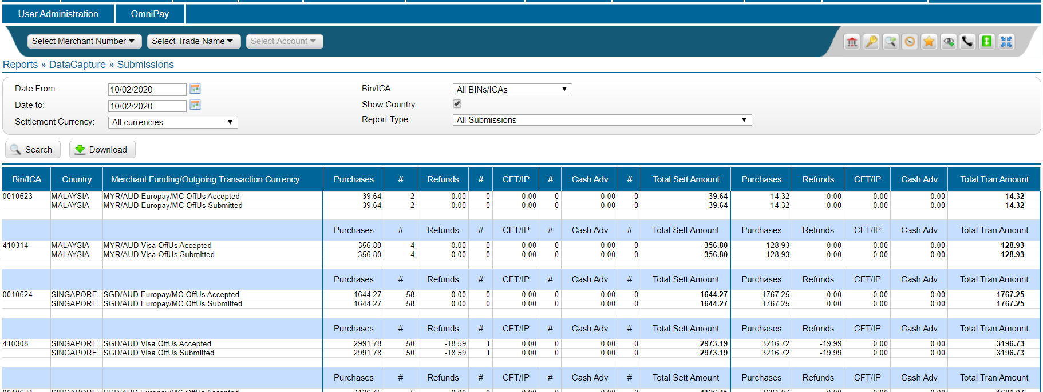

1. **Reports » Reconciliation » Outgoing Interchange Summary**
2. **MasterCard Reports for each ICA # 10622, 10624, 10623, 14100, 19758**

**Currency: HKD & USD for Hong Kong**

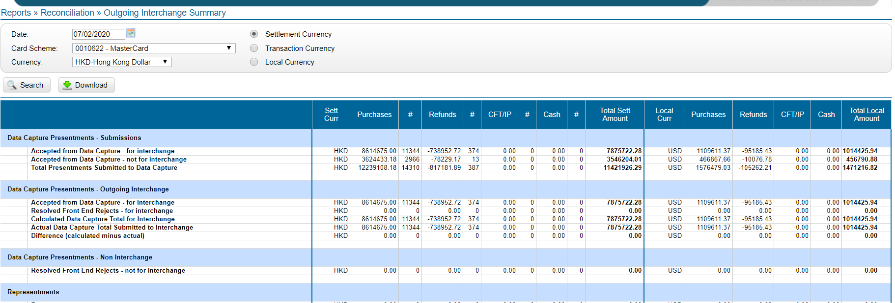

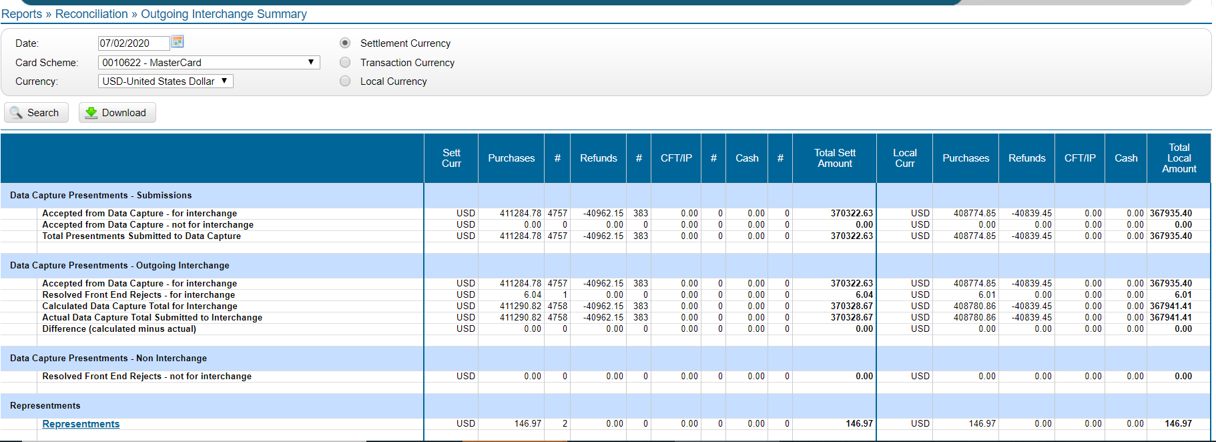

**Currency: SGD & USD for Singapore**

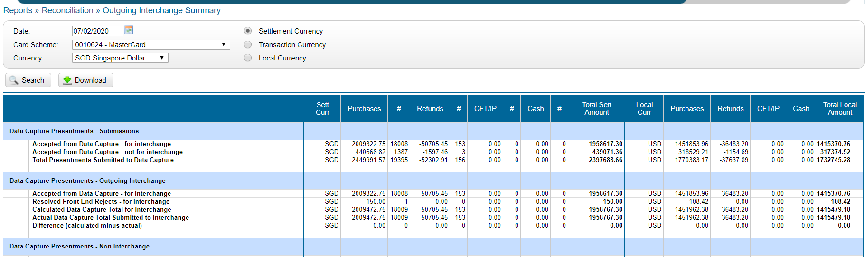

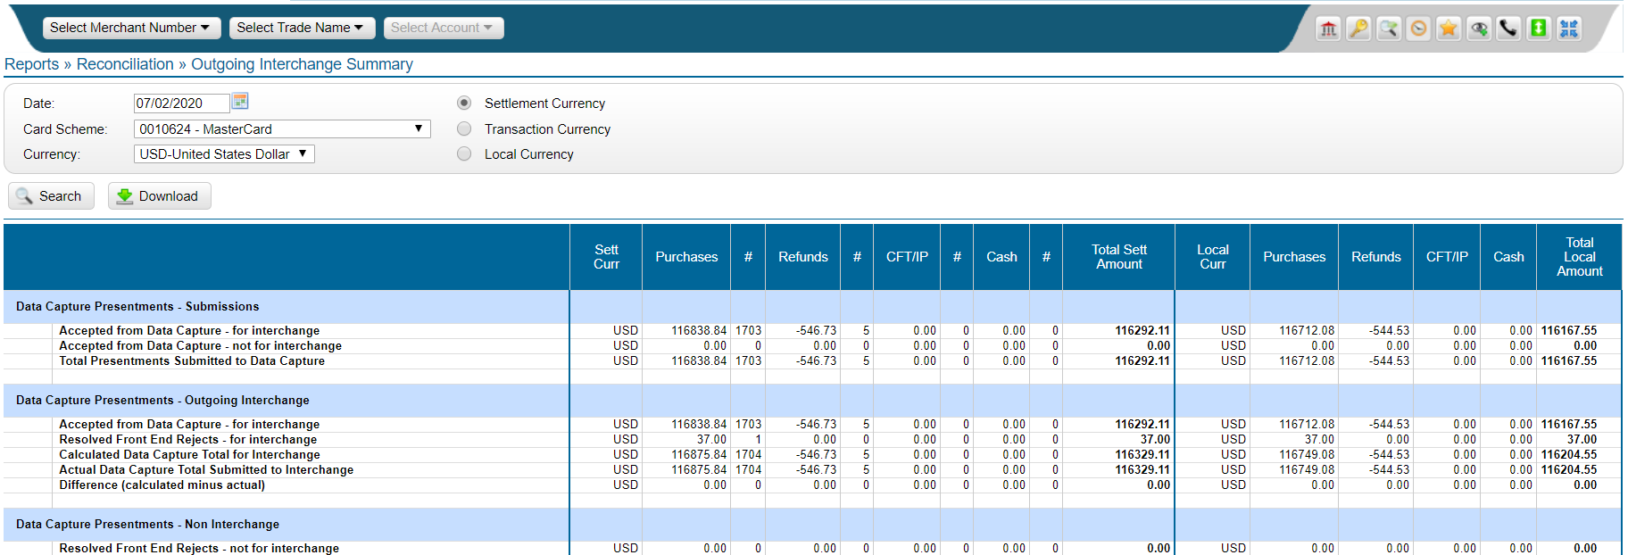

**Currency: MYR for Malaysia**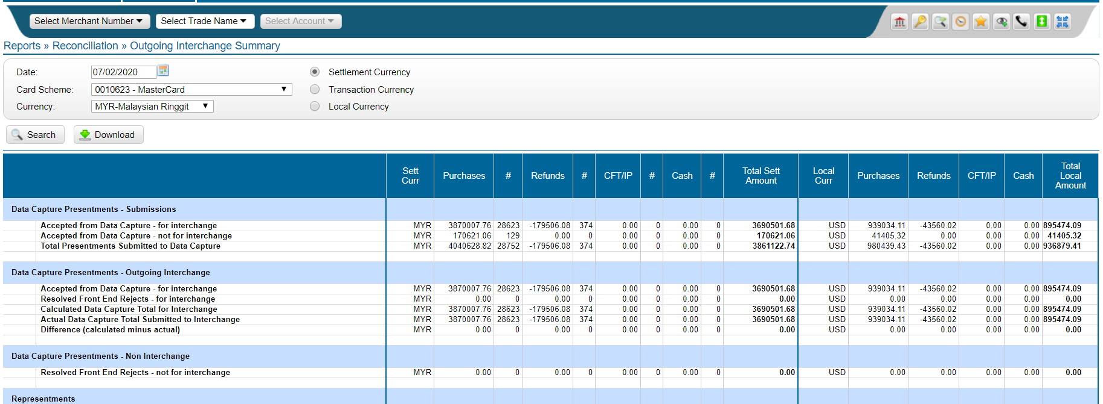

**Currency: HKD for Macau**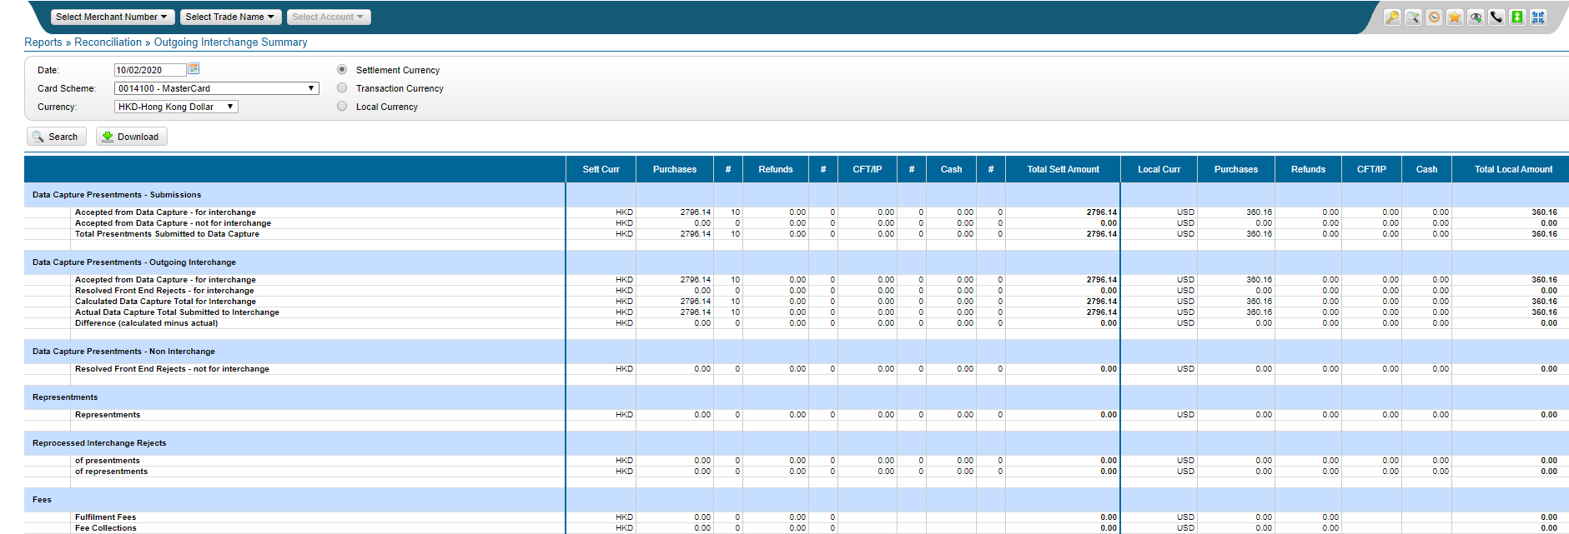

**Currency: HKD for CITIC**

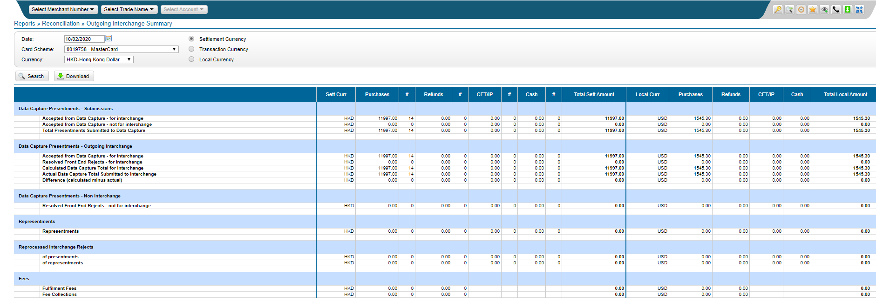

1. **Visa - 437799, 410308, 410314, 424633, 453515**

**Currency: HKD & USD for HongKong**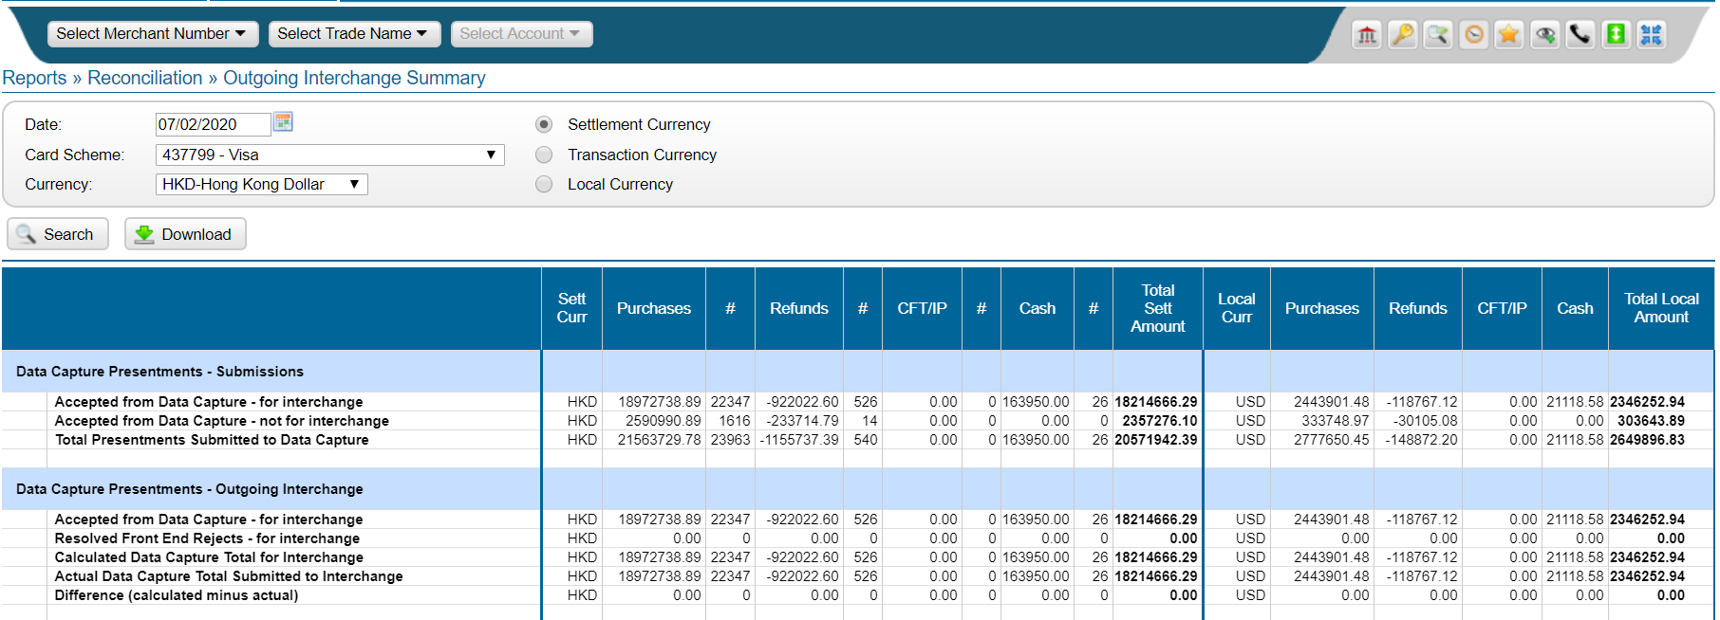

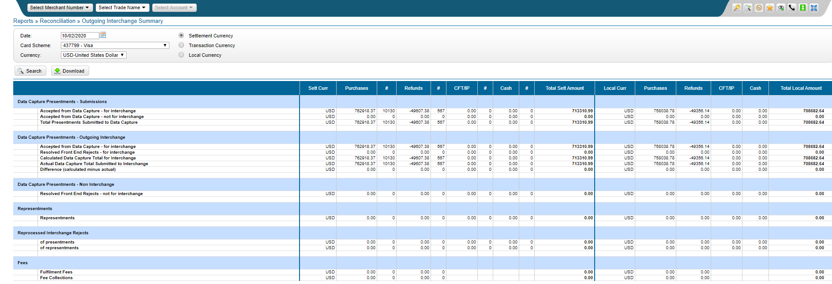

**Currency: SGD & USD for Singapore**

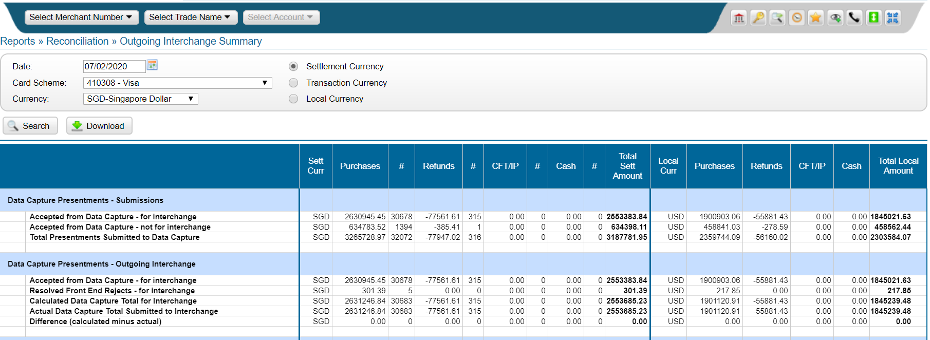

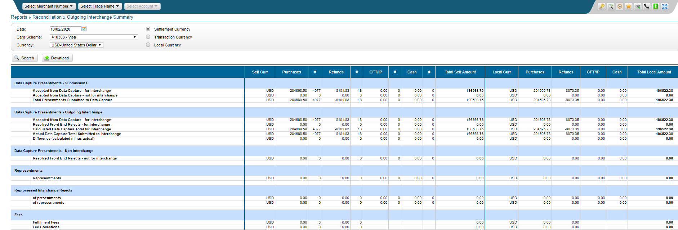

**Currency: HKD for Macau**

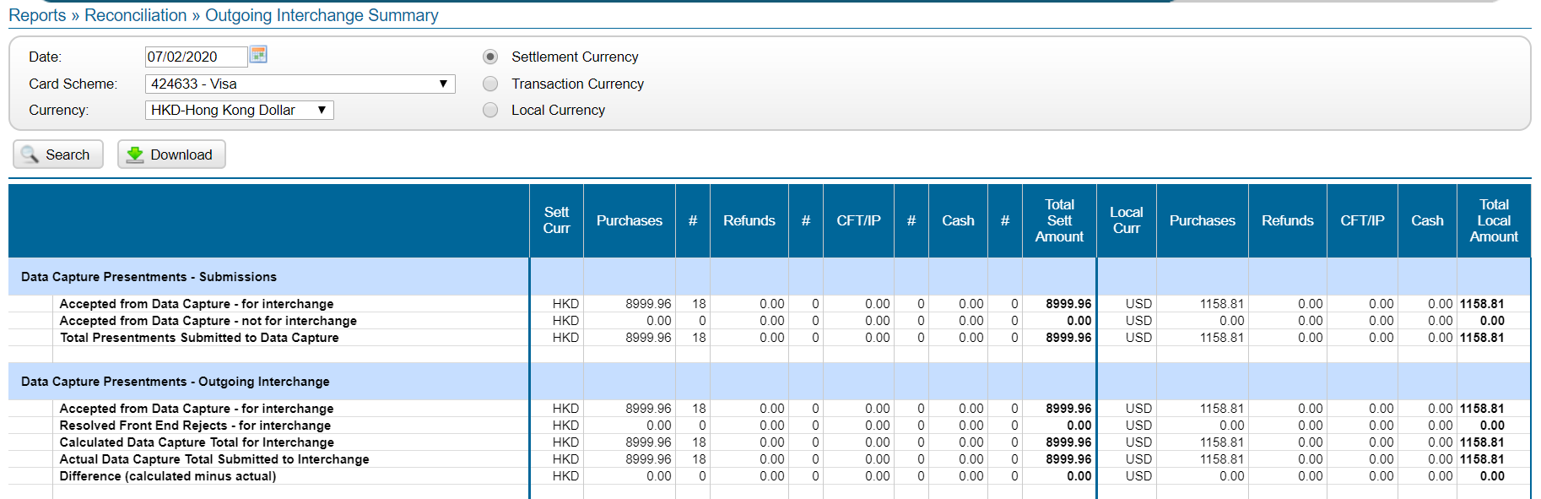

**Currency: HKD for CITIC**

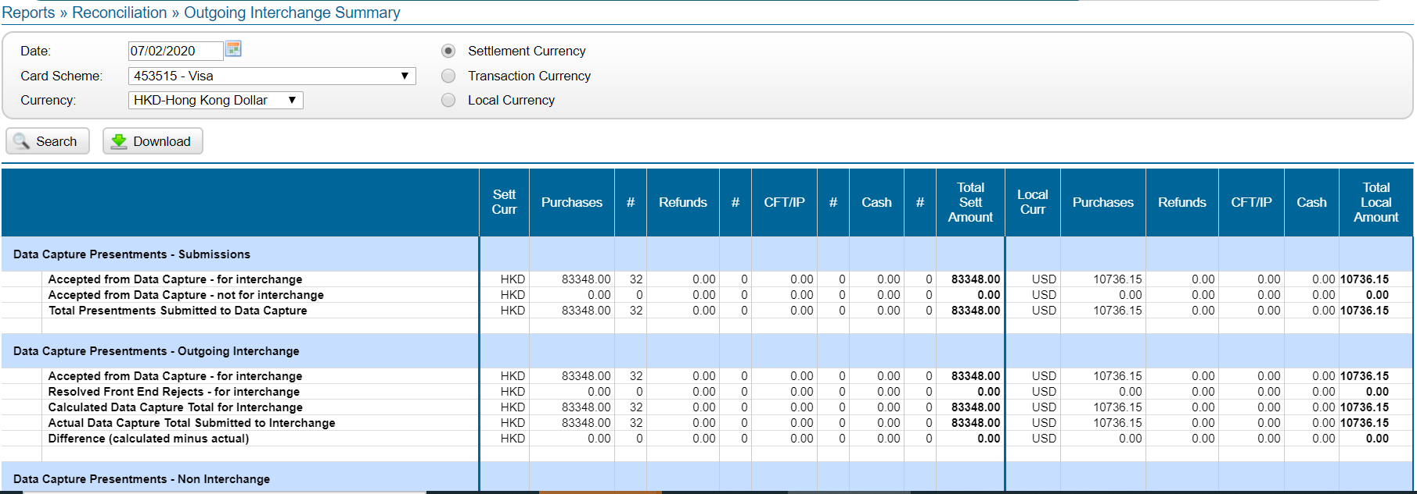

1. **All Submissions - China Union Pay**

**Currency: HKD & USD for Hong Kong**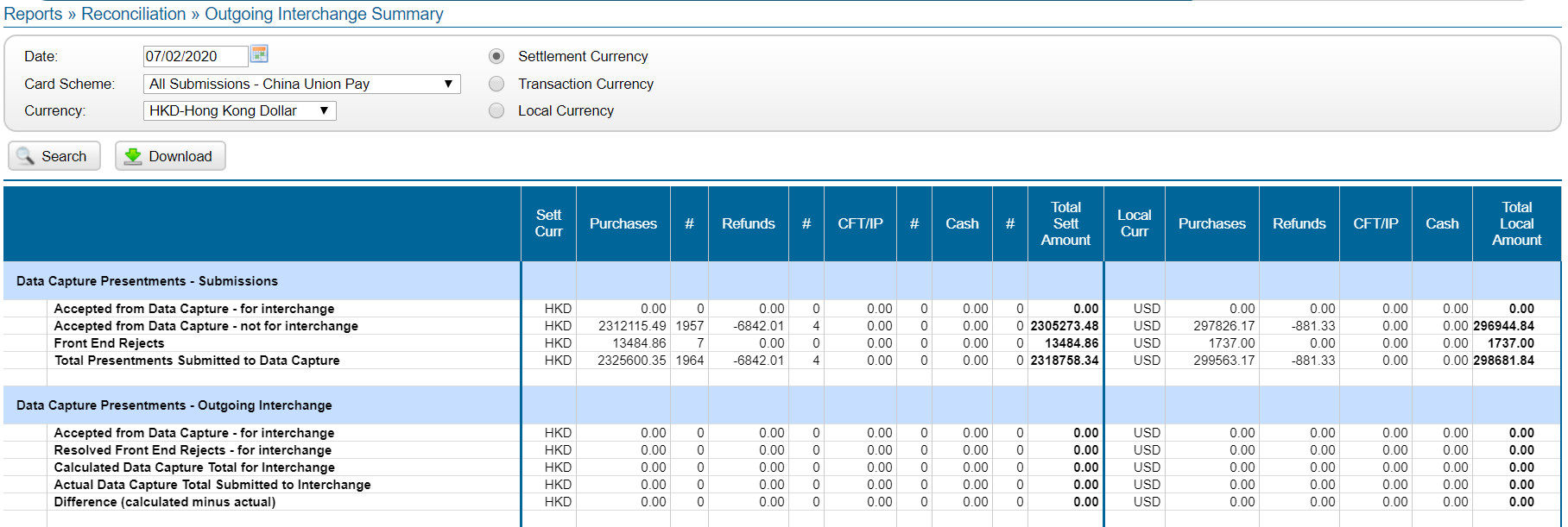

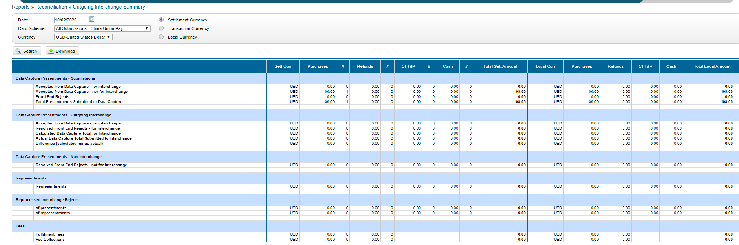

**Currency: SGD & USD for Singapore**

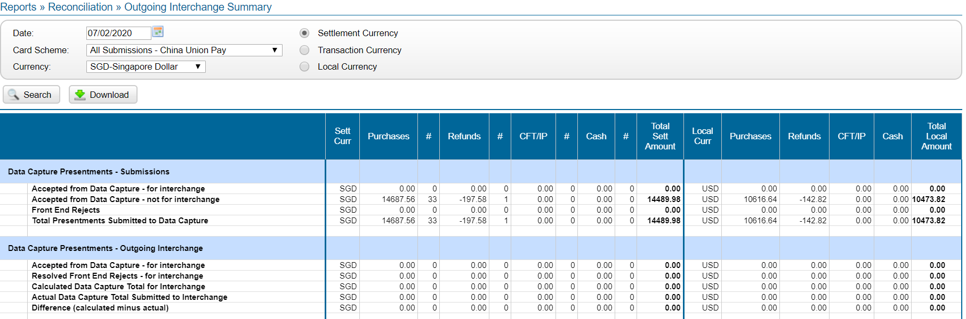

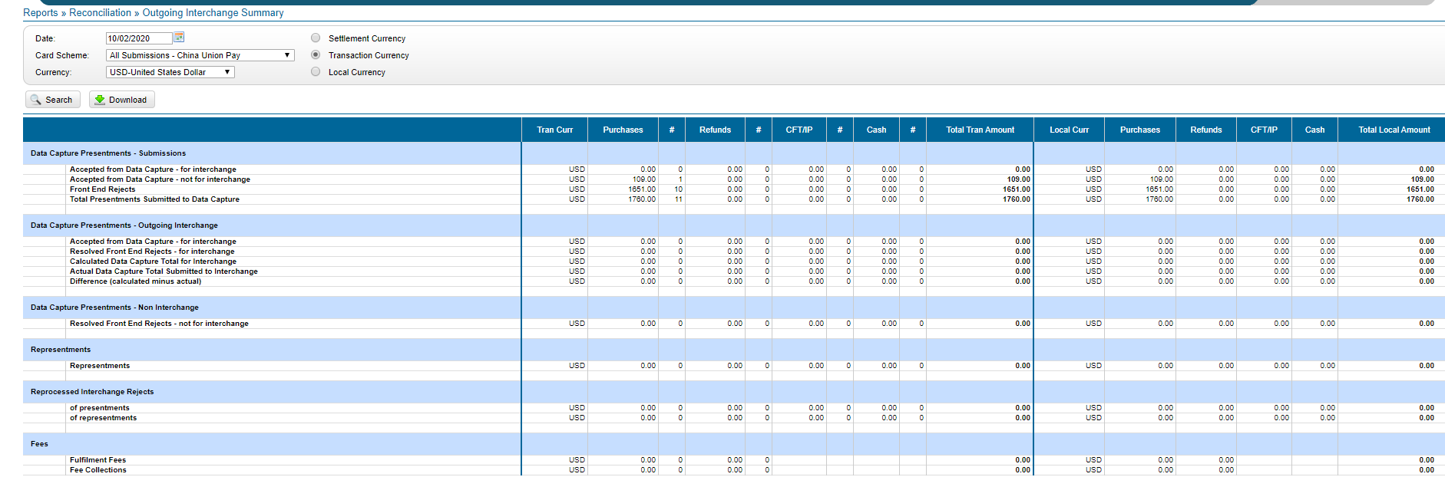

1. **JCB - 143101,143102,143103,143104,143401, 143201, 143301**

**Currency: HKD for Hong Kong**

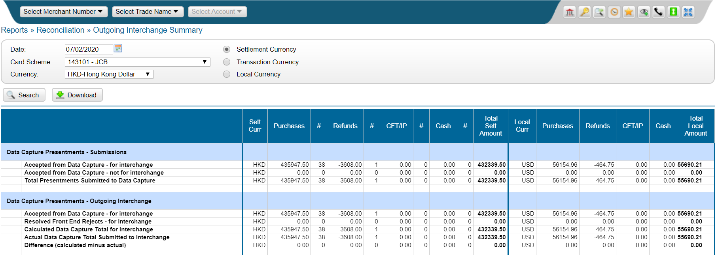

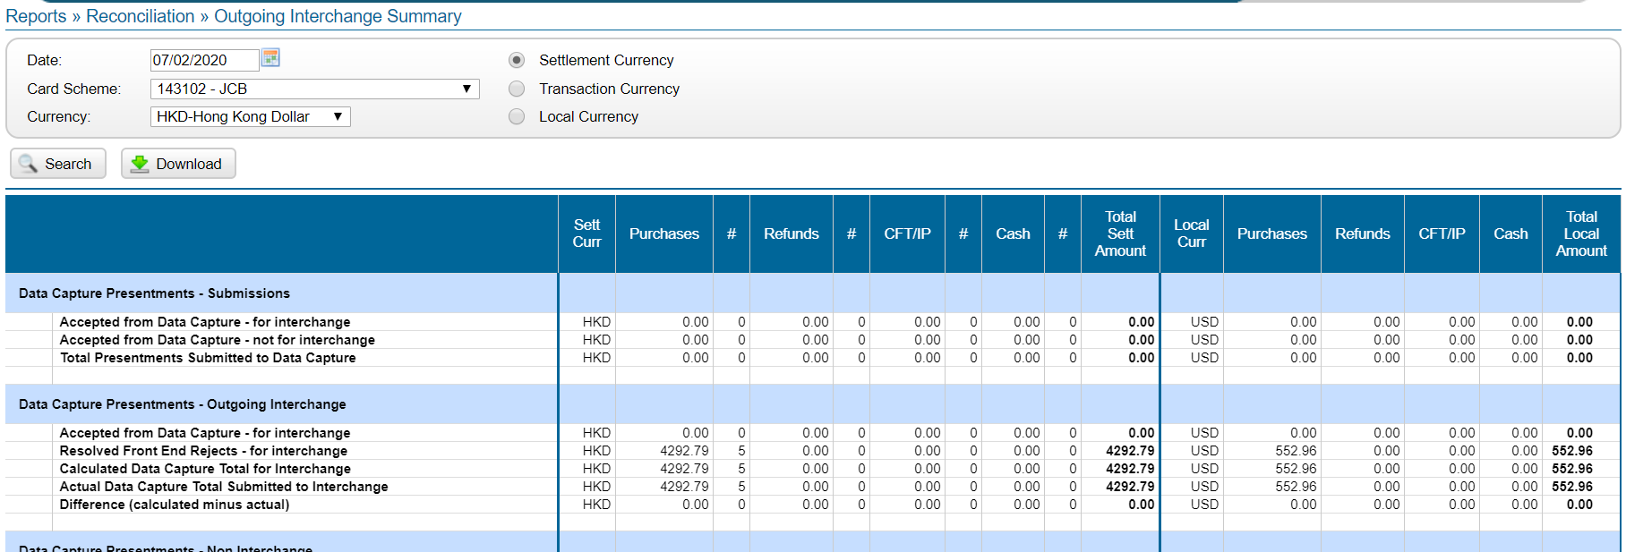

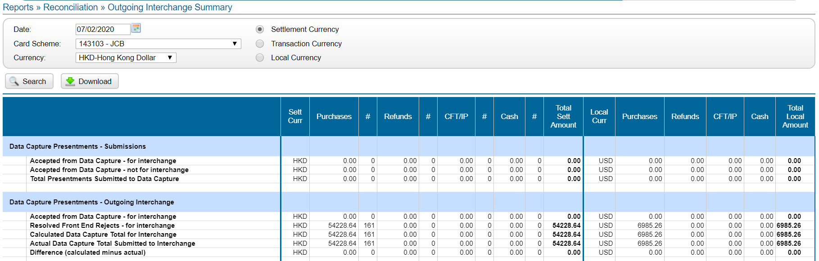

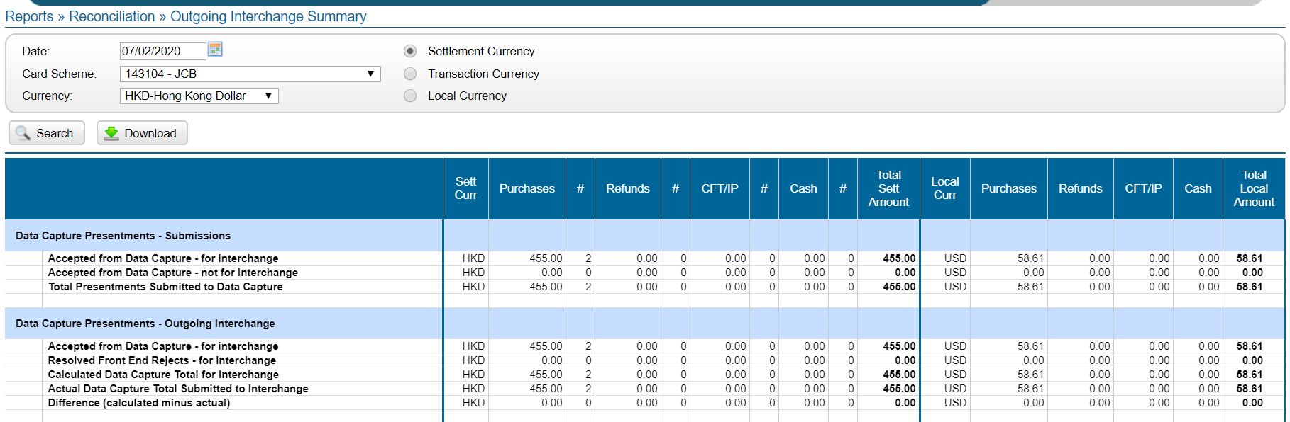

**Currency: HKD for Macau**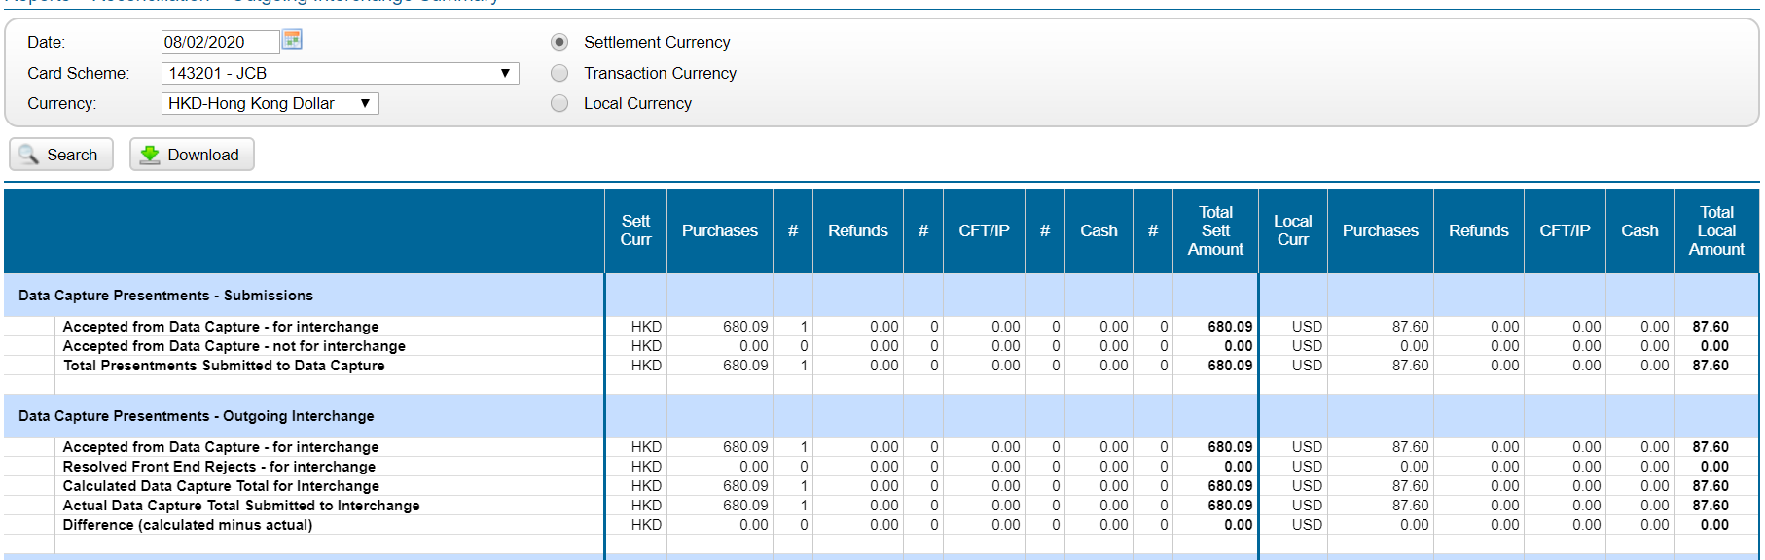

**Currency: USD for Malaysia**

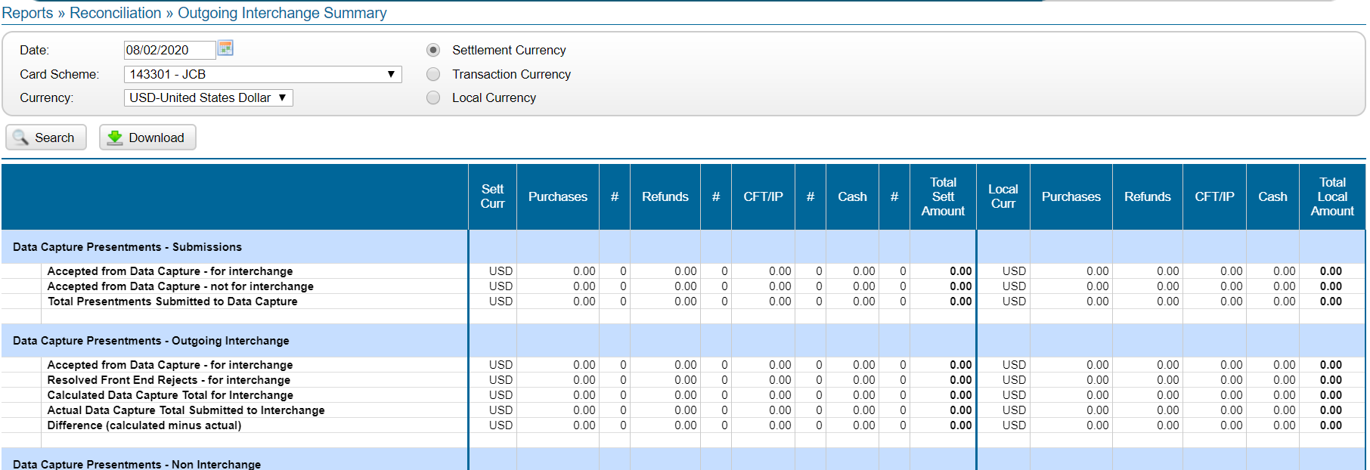

**Currency: SGD for Singapore**

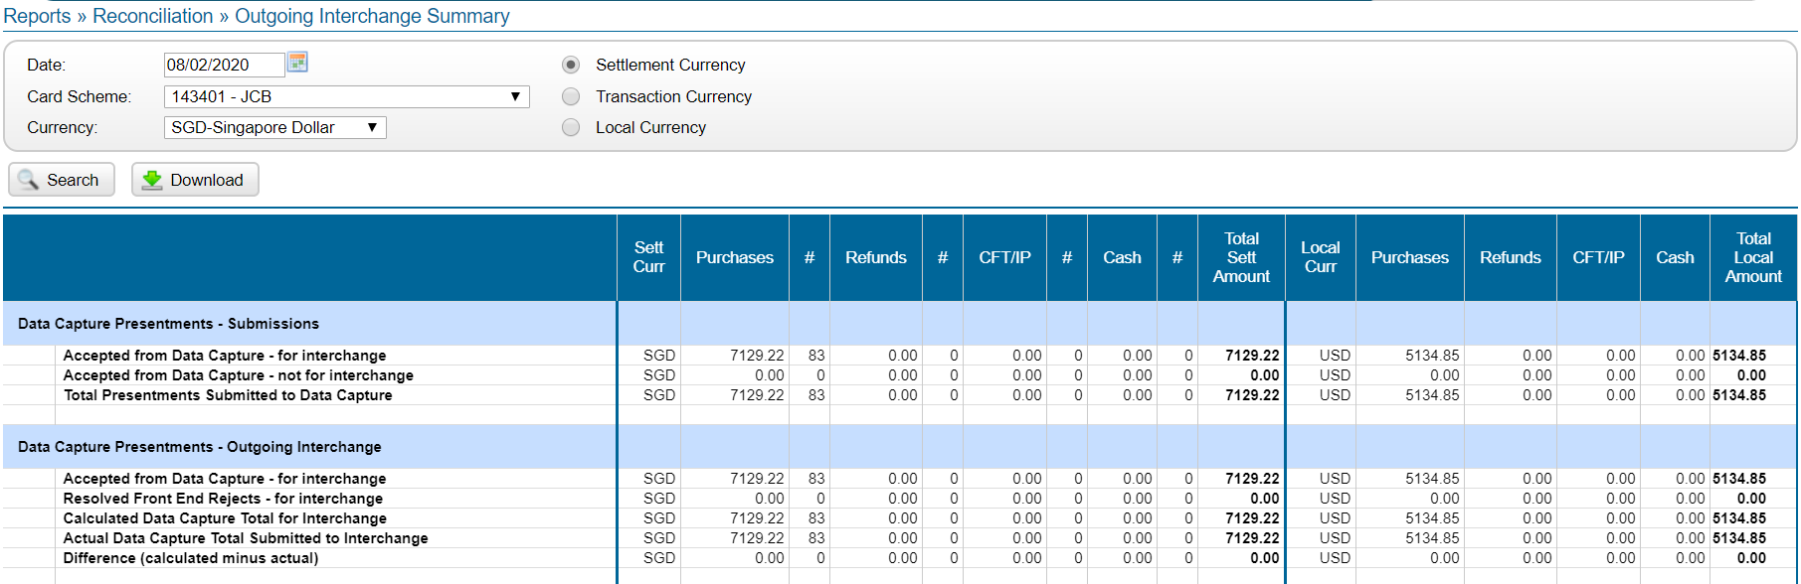

1. **All Interchange - Visa Onus (Settlement currency in HKD, SGD, MYR)**

**Currency: HKD for HongKong**

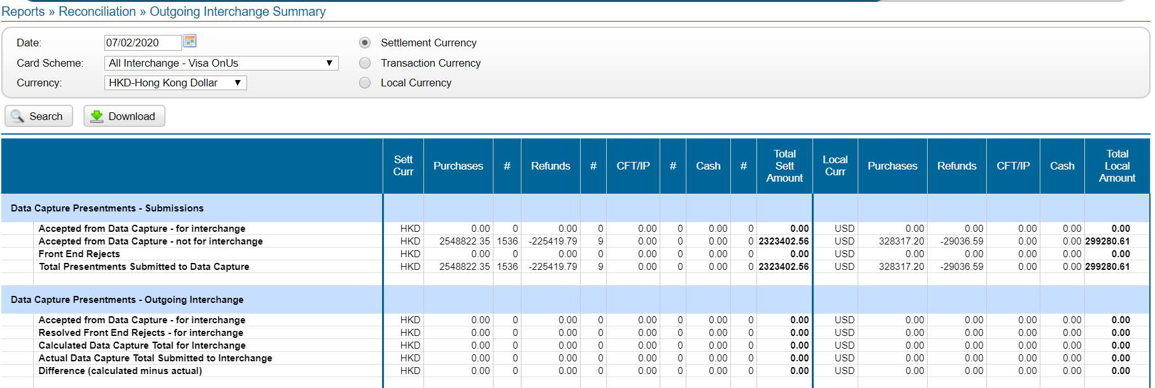

**Currency: SGD for Singapore**

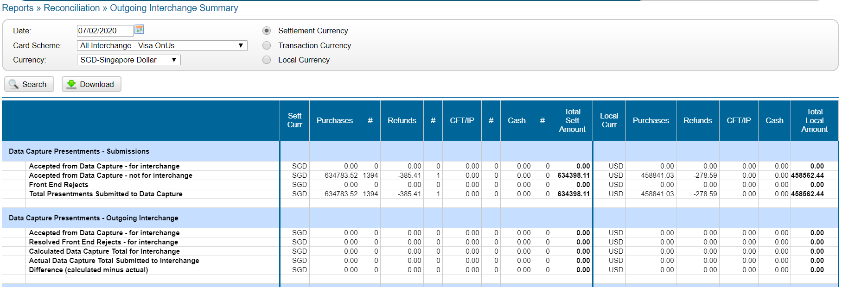

**Currency: MYR for Malaysia**

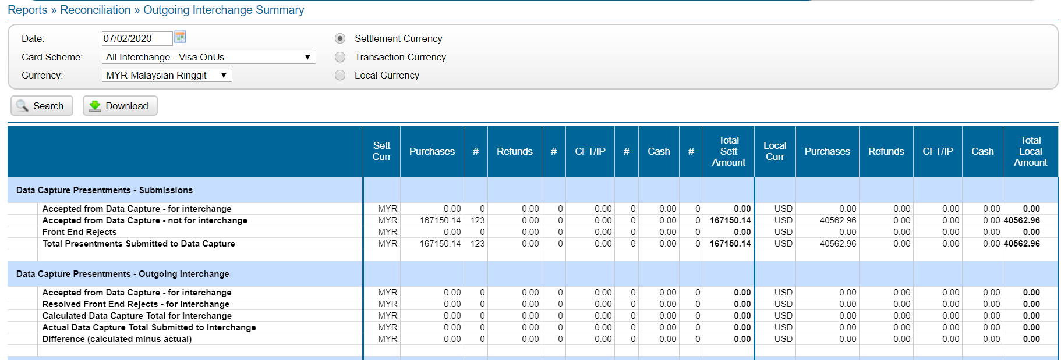

1. **All Interchange - MasterCard Onus (Settlement currency in HKD, SGD, MYR)**

**Currency: HKD for HongKong**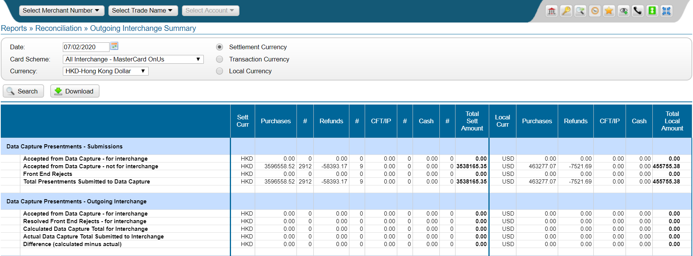

**Currency: SGD for Singapore**

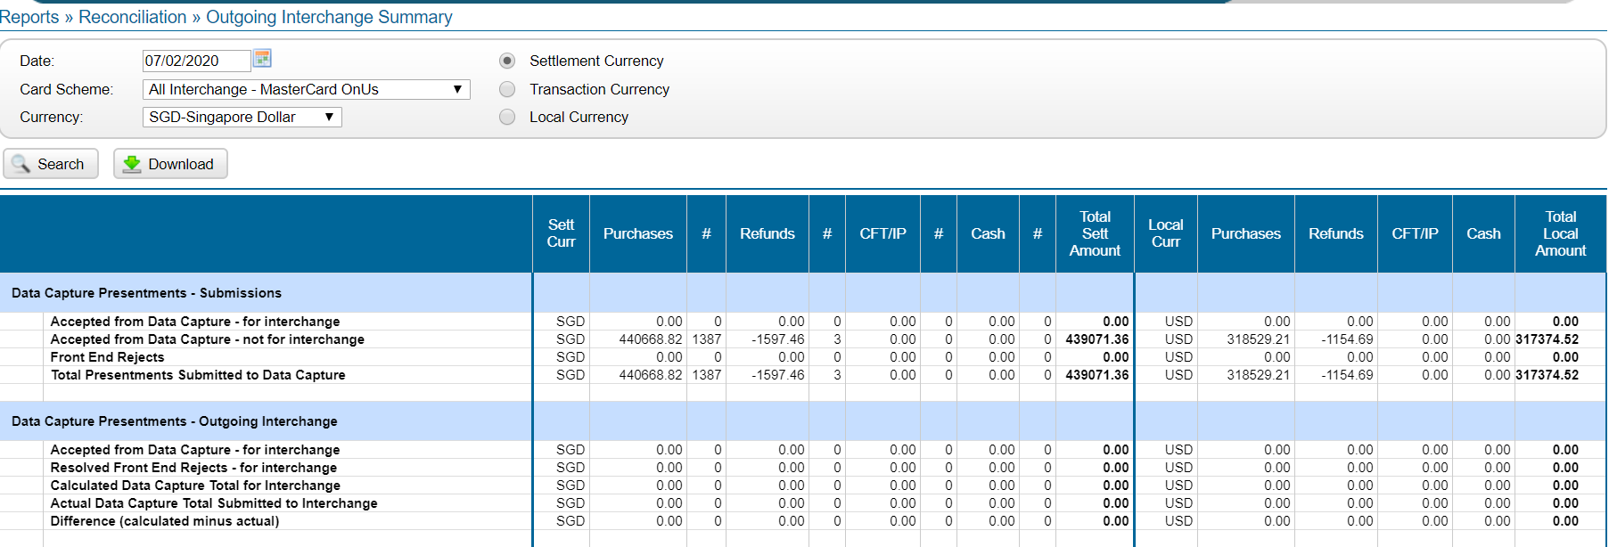

**Currency: MYR for Malaysia**

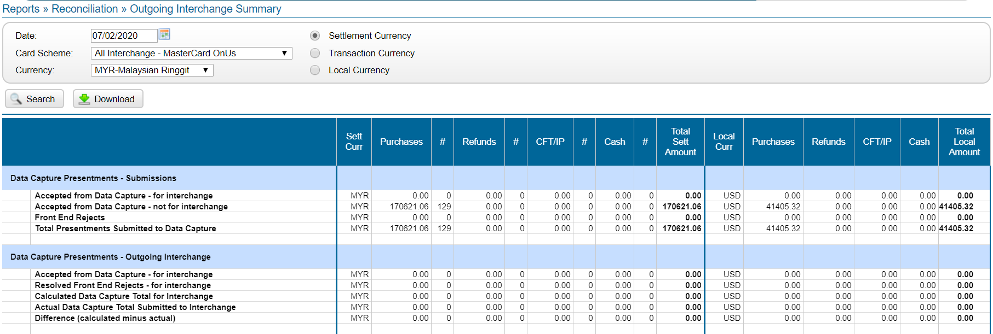

1. **Reports » Reconciliation » Incoming Scheme Settlement**

**All-Visa**

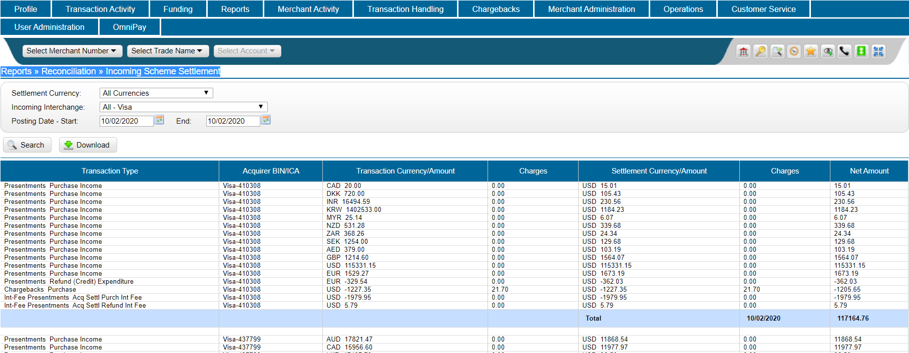

**All-Mastercard**

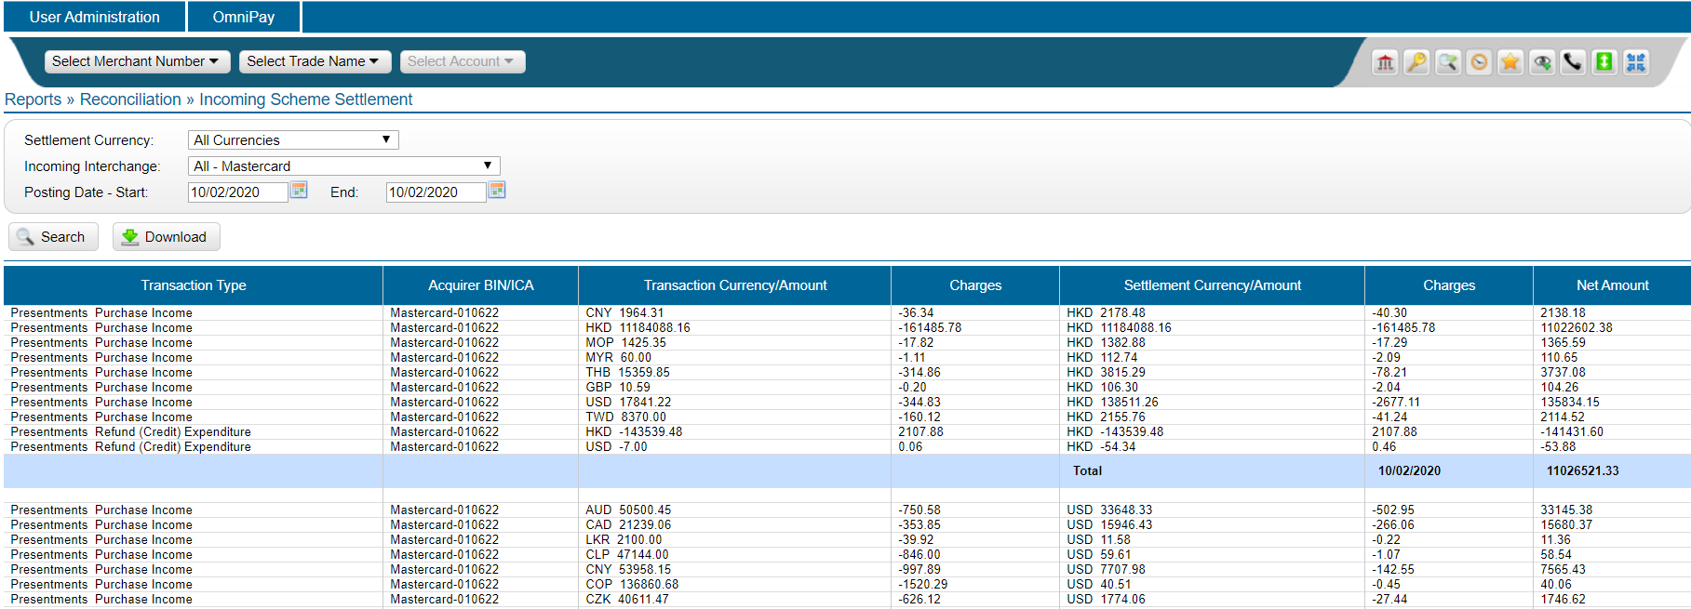

**Reports » Reconciliation » Interchange Rejects Detail**

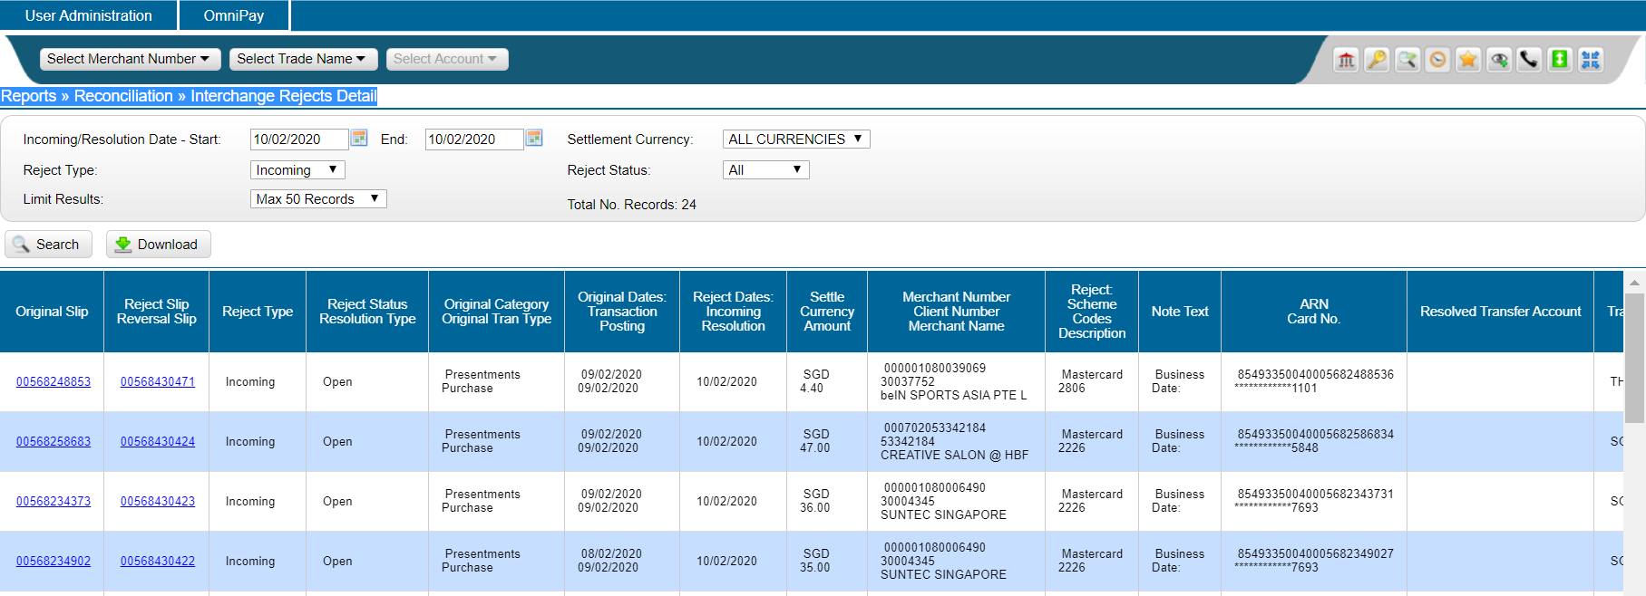

1. **Reports » Static Reporting » External Report List**
2. **IPM Clearing Cycle Acknowledgement (Master)**

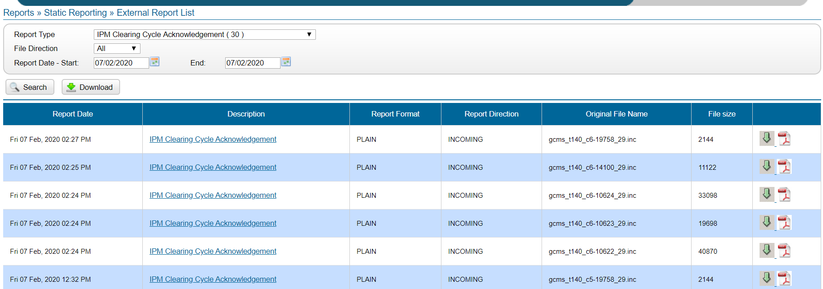

1. **Visa Incoming Settlement Report (Visa)**

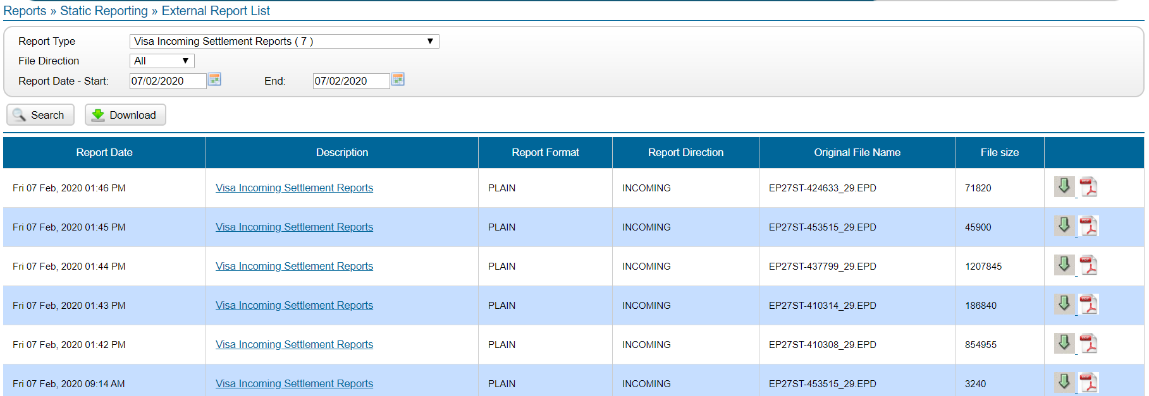

1. **JCB Settlement Report(Detail information)**

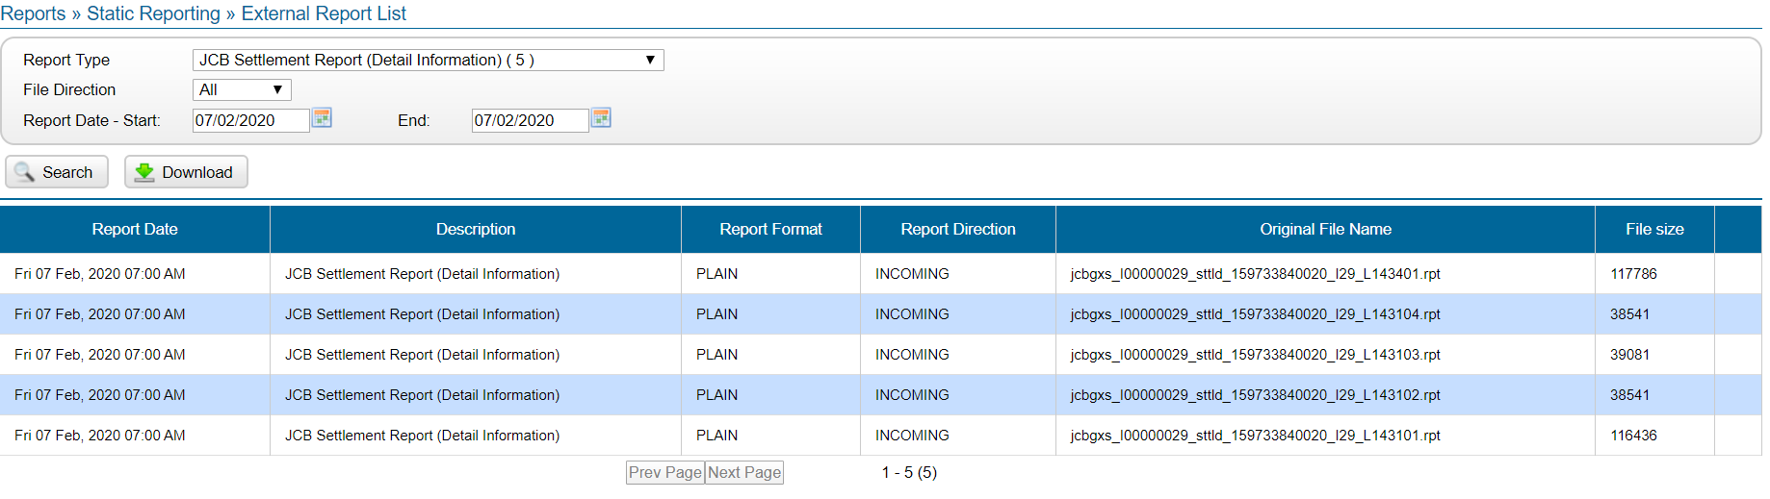

**D) IPM Clearing Cycle Reject Detail**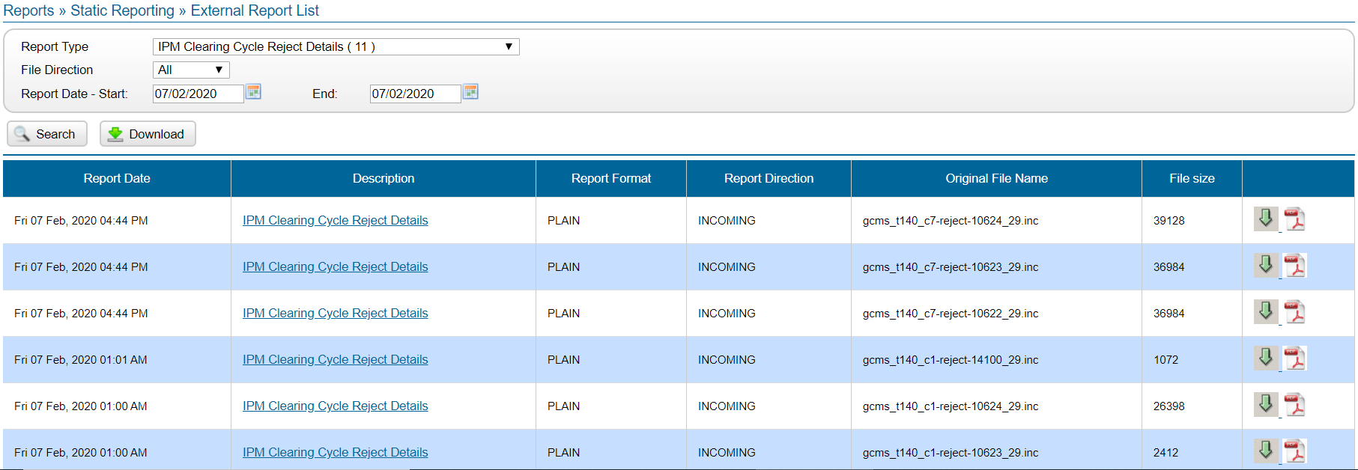

**E) Reports » Static Reporting » External Report List » Merchant Outstanding Funding Report**

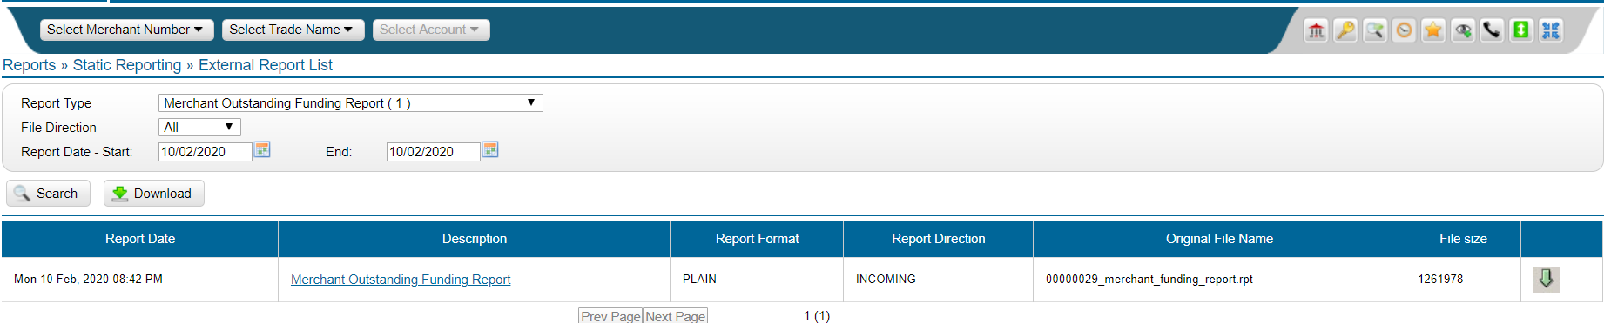

**f) Reports » Static Reporting » External Report List »** [**Settlement - Clearing and Funding Detail**](https://www.omnipaygroup.com/ramtool?cmd=link&prevpage=EXTERNAL_REPORT_LIST&nextpage=REPORT_DETAIL&48BC2=2020021022875554&37bls=963a2862cfcb04d84e1f90f28e5d14000468bbc0618a54fe030f06db3b5a29c873e5e7e62bb7a66064a425d16a8da401d7b5737e49a021b44f1854b5d460b54c)

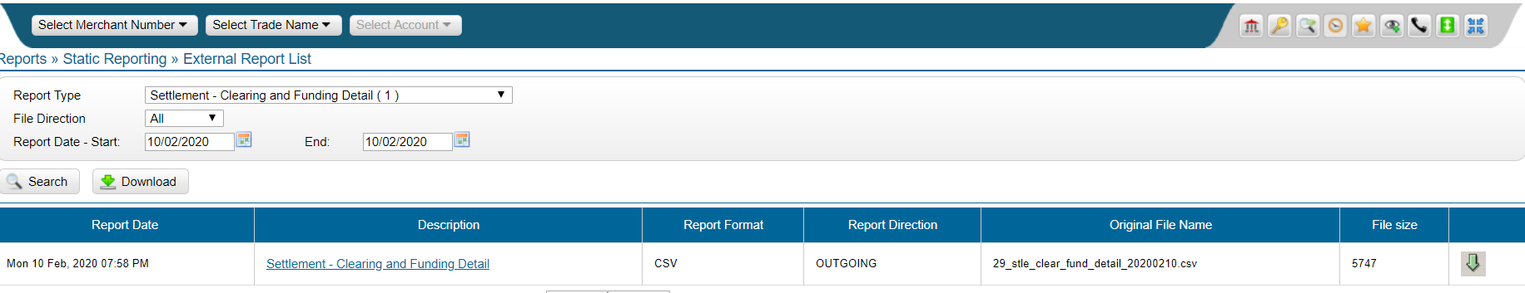

**g) Reports » Static Reporting » External Report List »** [**Outgoing Transaction Journal Report (CSV)**](https://www.omnipaygroup.com/ramtool?cmd=link&prevpage=EXTERNAL_REPORT_LIST&nextpage=REPORT_DETAIL&48BC2=2020021022875145&37bls=963a2862cfcb04d84e1f90f28e5d14000468bbc0618a54fe030f06db3b5a29c873e5e7e62bb7a66064a425d16a8da401d7b5737e49a021b44f1854b5d460b54c)

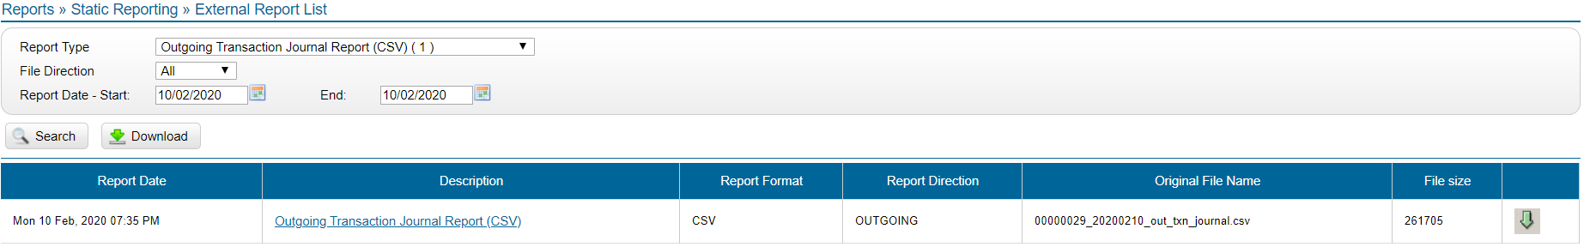

**h) Reports » Static Reporting » External Report List »** [**Settlement - Visa Outgoing Vs Incoming**](https://www.omnipaygroup.com/ramtool?cmd=link&prevpage=EXTERNAL_REPORT_LIST&nextpage=REPORT_DETAIL&48BC2=2020021022872931&37bls=963a2862cfcb04d84e1f90f28e5d14000468bbc0618a54fe030f06db3b5a29c873e5e7e62bb7a66064a425d16a8da401d7b5737e49a021b44f1854b5d460b54c)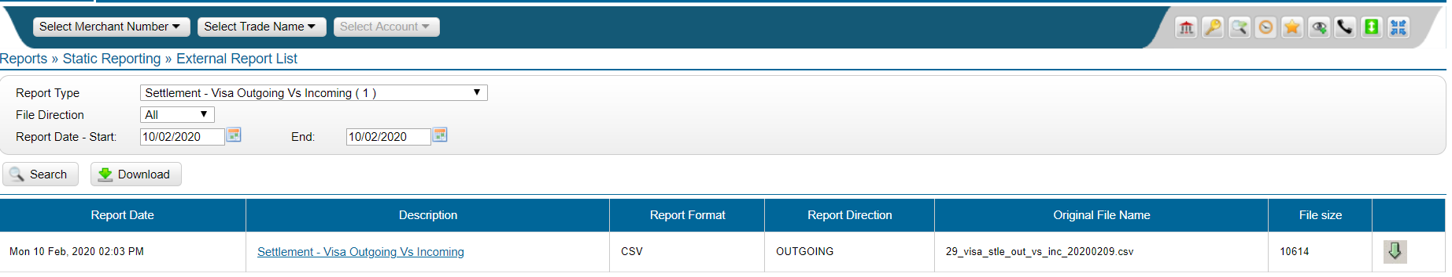

**i) Reports » Static Reporting » External Report List »** [[**Settlement - MasterCard Outgoing Vs Incoming**](https://www.omnipaygroup.com/ramtool?cmd=link&prevpage=EXTERNAL_REPORT_LIST&nextpage=REPORT_DETAIL&48BC2=2020021022873817&37bls=963a2862cfcb04d84e1f90f28e5d14000468bbc0618a54fe030f06db3b5a29c873e5e7e62bb7a66064a425d16a8da401d7b5737e49a021b44f1854b5d460b54c)](https://www.omnipaygroup.com/ramtool?cmd=link&prevpage=EXTERNAL_REPORT_LIST&nextpage=REPORT_DETAIL&48BC2=2020021022872931&37bls=963a2862cfcb04d84e1f90f28e5d14000468bbc0618a54fe030f06db3b5a29c873e5e7e62bb7a66064a425d16a8da401d7b5737e49a021b44f1854b5d460b54c)

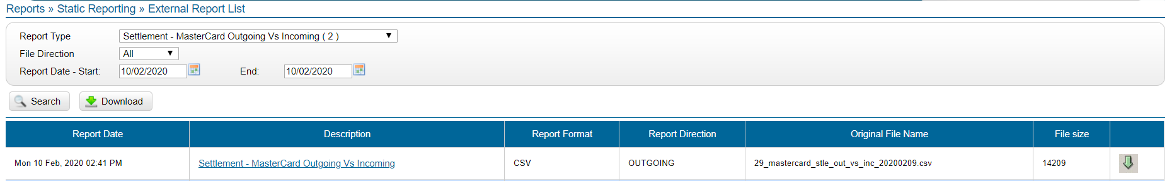

**j) Reports » Static Reporting » External Report List »** [**Visa Settlement Information Report (CSV)**](https://www.omnipaygroup.com/ramtool?cmd=link&prevpage=EXTERNAL_REPORT_LIST&nextpage=REPORT_DETAIL&48BC2=2020021022872925&37bls=963a2862cfcb04d84e1f90f28e5d14000468bbc0618a54fe030f06db3b5a29c873e5e7e62bb7a66064a425d16a8da401d7b5737e49a021b44f1854b5d460b54c)

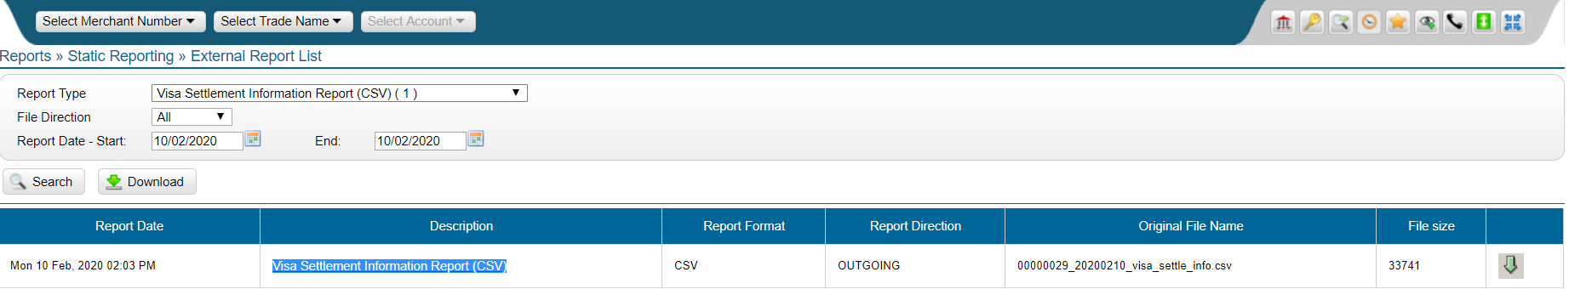

**K) Reports » Static Reporting » External Report List »** [**IPM Settlement Information Report (CSV)**](https://www.omnipaygroup.com/ramtool?cmd=link&prevpage=EXTERNAL_REPORT_LIST&nextpage=REPORT_DETAIL&48BC2=2020021022873791&37bls=963a2862cfcb04d84e1f90f28e5d14000468bbc0618a54fe030f06db3b5a29c873e5e7e62bb7a66064a425d16a8da401d7b5737e49a021b44f1854b5d460b54c)

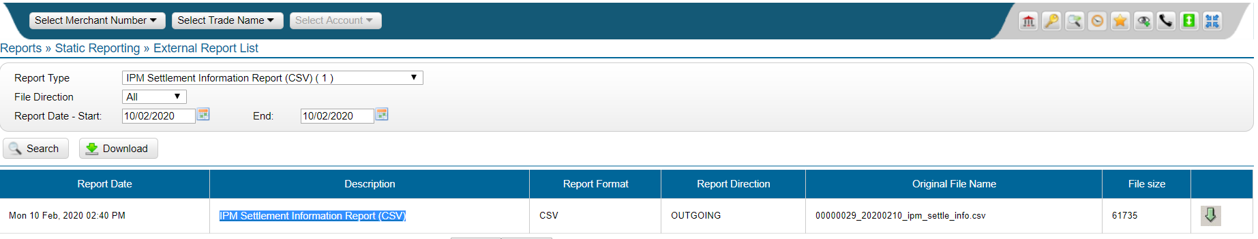

**l) Reports » Static Reporting » External Report List »** [**Deleted Payments Report**](https://www.omnipaygroup.com/ramtool?cmd=link&prevpage=EXTERNAL_REPORT_LIST&nextpage=REPORT_DETAIL&48BC2=2020021022872082&37bls=963a2862cfcb04d84e1f90f28e5d14000468bbc0618a54fe030f06db3b5a29c873e5e7e62bb7a66064a425d16a8da401d7b5737e49a021b44f1854b5d460b54c)

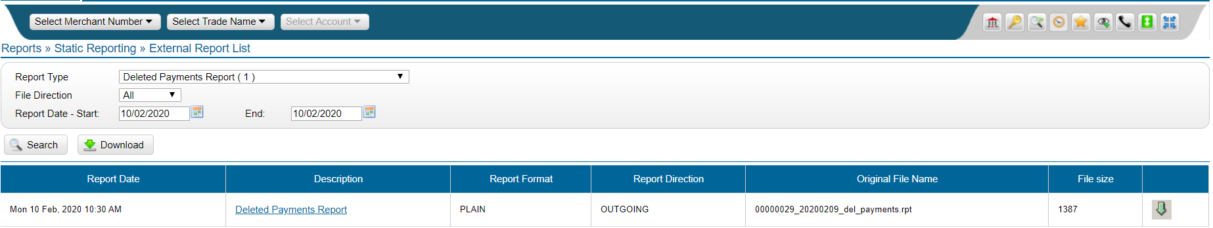

**m) Reports » Static Reporting » External Report List »** [**FDMS Macau Funding File**](https://www.omnipaygroup.com/ramtool?cmd=link&prevpage=EXTERNAL_REPORT_LIST&nextpage=REPORT_DETAIL&48BC2=2020021022871343&37bls=963a2862cfcb04d84e1f90f28e5d14000468bbc0618a54fe030f06db3b5a29c873e5e7e62bb7a66064a425d16a8da401d7b5737e49a021b44f1854b5d460b54c)

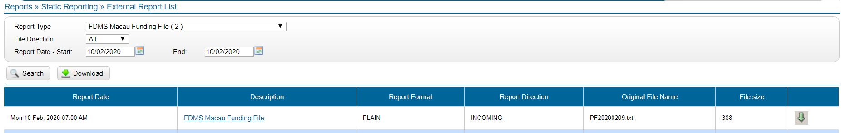

**n) Reports » Static Reporting » External Report List »** [**FDMS Macau Funding Recon file**](https://www.omnipaygroup.com/ramtool?cmd=link&prevpage=EXTERNAL_REPORT_LIST&nextpage=REPORT_DETAIL&48BC2=2020021022871342&37bls=963a2862cfcb04d84e1f90f28e5d14000468bbc0618a54fe030f06db3b5a29c873e5e7e62bb7a66064a425d16a8da401d7b5737e49a021b44f1854b5d460b54c)

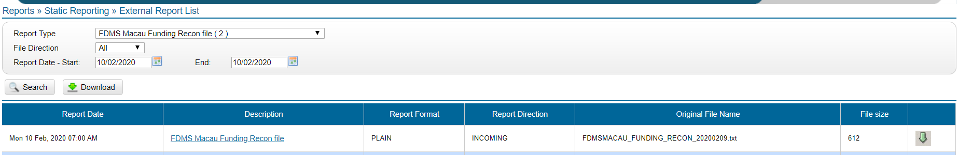

**o) Reports » Static Reporting » External Report List »** [**Billing Merchant Balance Report**](https://www.omnipaygroup.com/ramtool?cmd=link&prevpage=EXTERNAL_REPORT_LIST&nextpage=REPORT_DETAIL&48BC2=2020021022870069&37bls=963a2862cfcb04d84e1f90f28e5d14000468bbc0618a54fe030f06db3b5a29c873e5e7e62bb7a66064a425d16a8da401d7b5737e49a021b44f1854b5d460b54c)

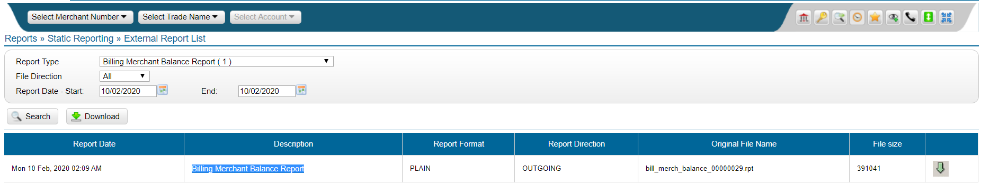

**6. Merchant Activity » Presentment Interchange Summary**

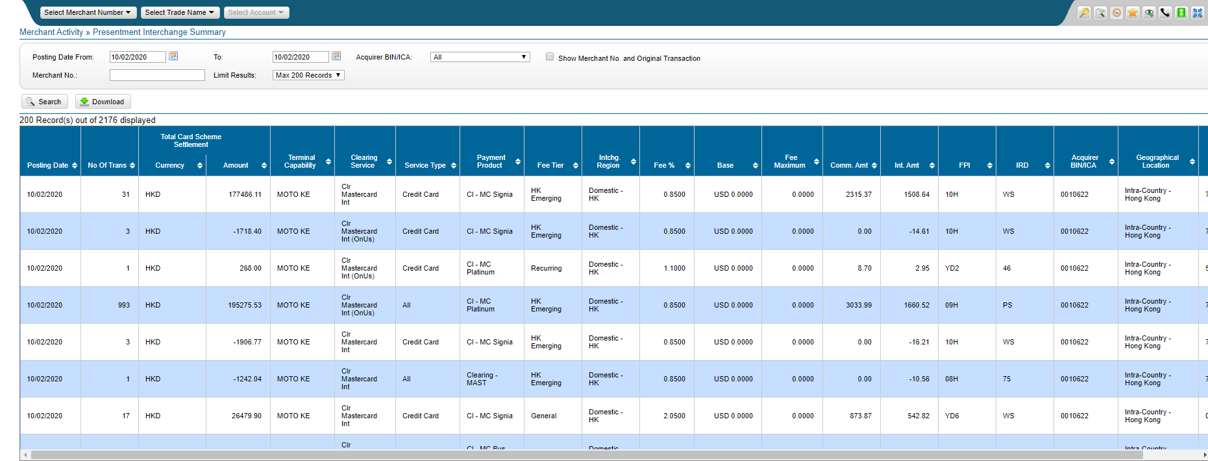

1. **Funding » Account**

**For Posting Date for 11900001 - HKD PAR for Hong Kong**

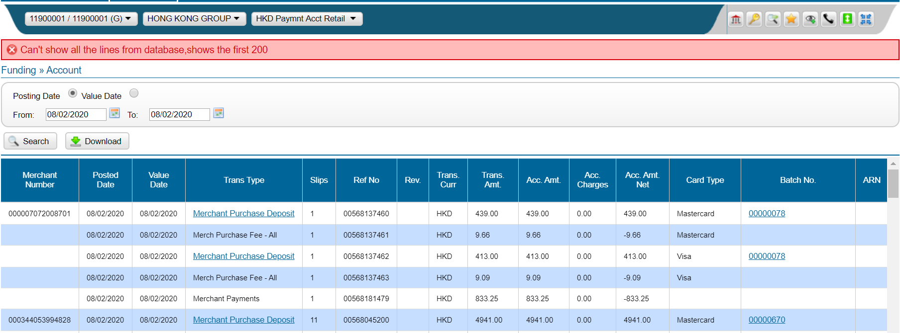

**For Posting Date for 11900001 - USD PAR for Hong Kong**

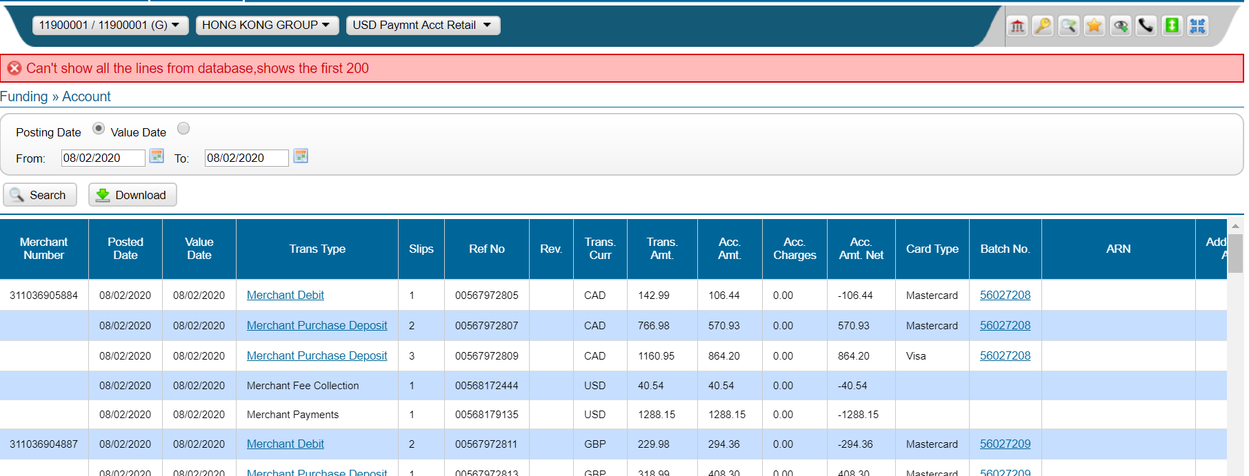

**For Posting Date for 12900001 - MOP PAR for Macau**

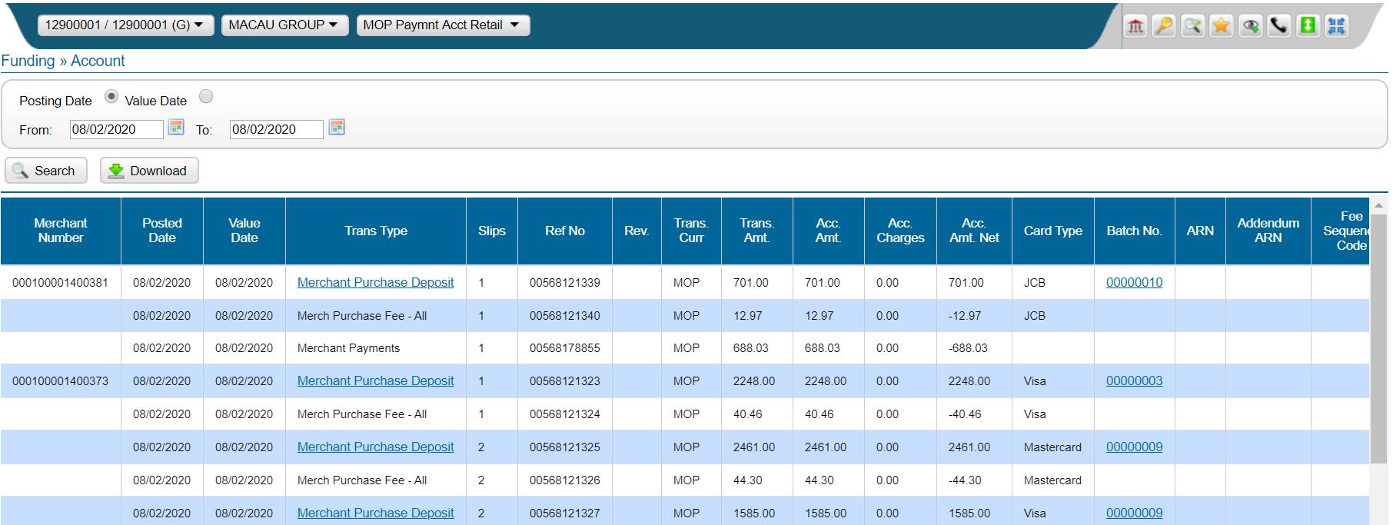

**For Posting Date 13900001 -SGD PAR for Singapore**

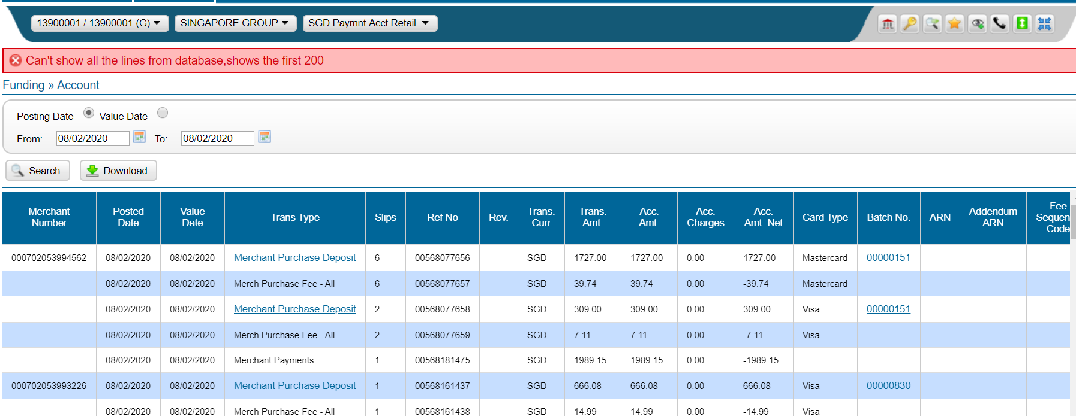

**For Posting Date 13900001 - USD PAR for Singapore**

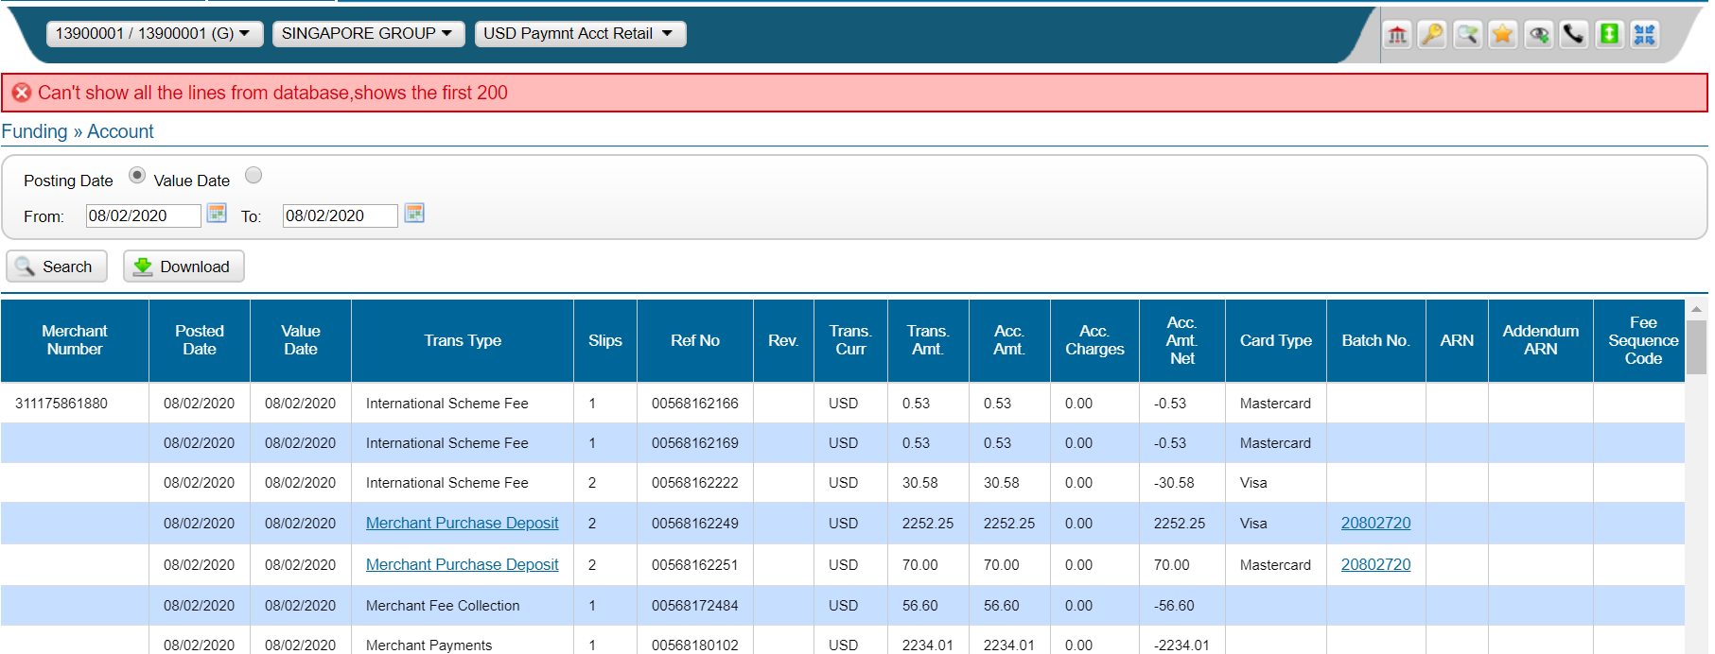

**For Posting Date 15900001 - MYR PAR for Malaysia**

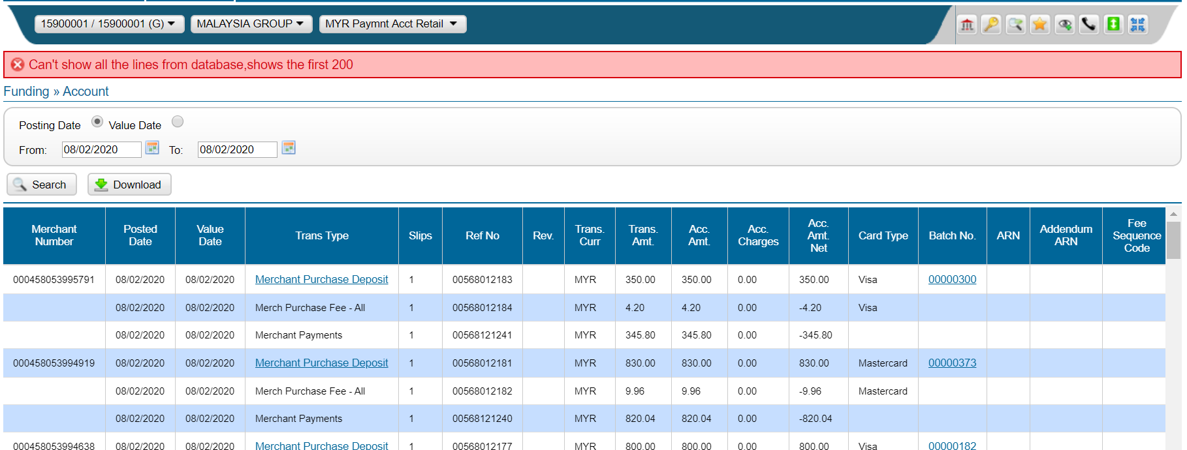

**For Posting Date 20900001-HK CITIC for HongKong**

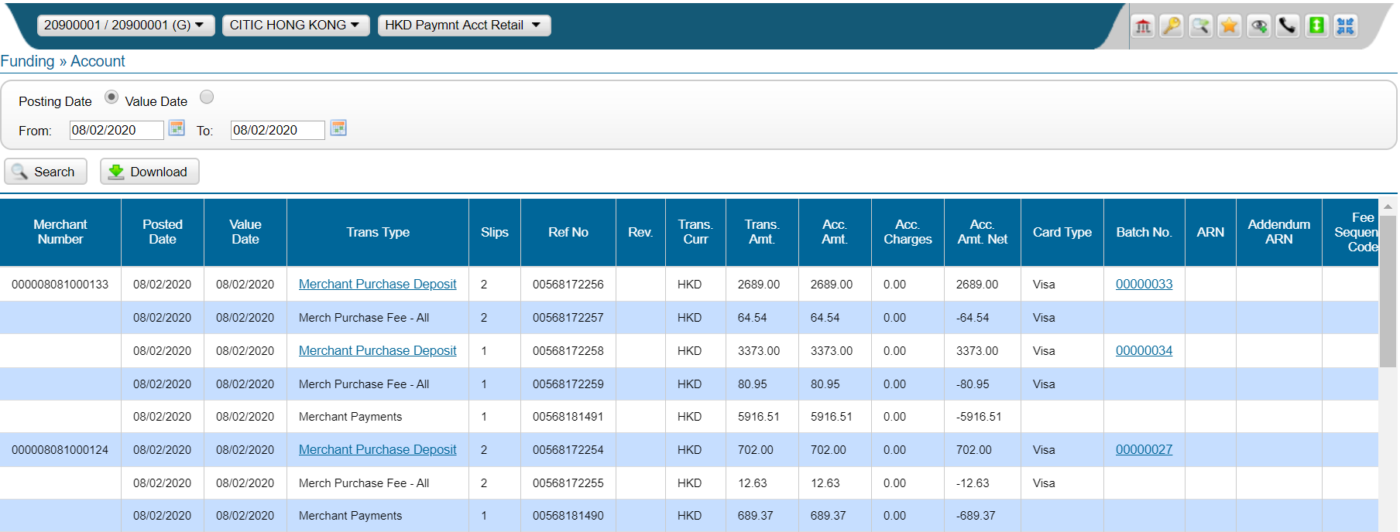

1. **Reports » Funding » Daily Funding**

**For Posting Date for 11900001 - HKD PAR for HongKong**

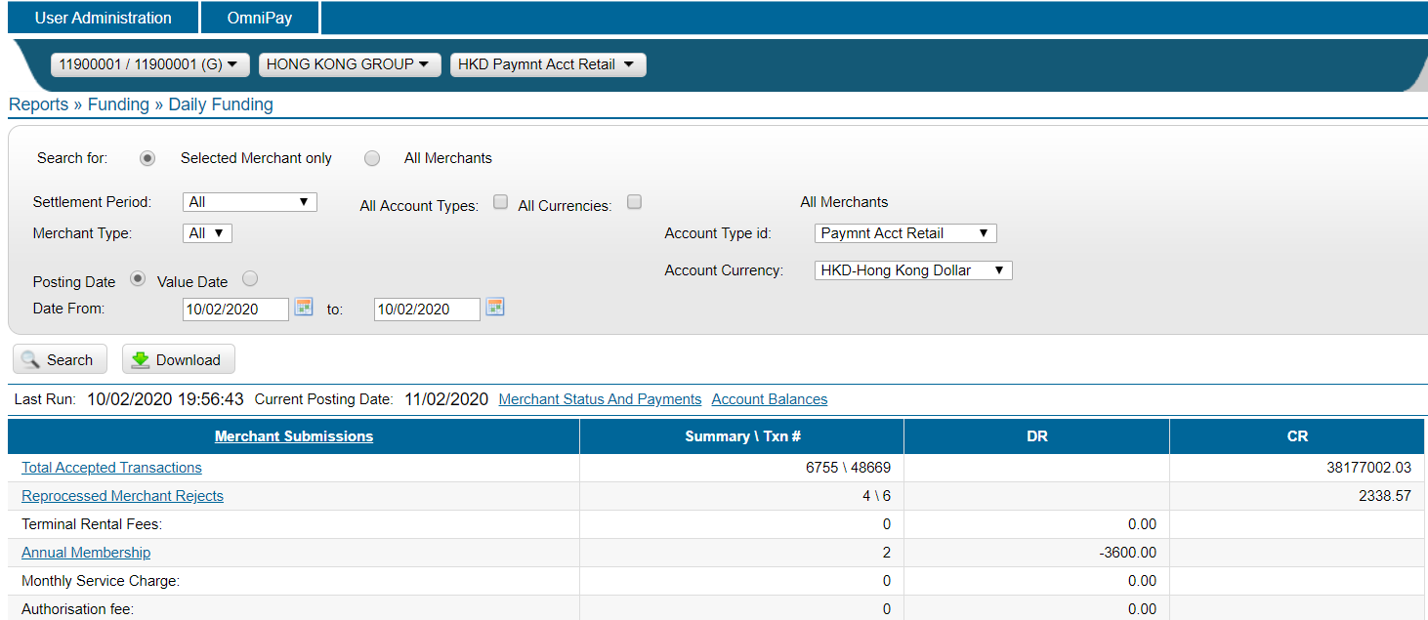

**For Posting Date for 11900001 - USD PAR for Hong Kong**

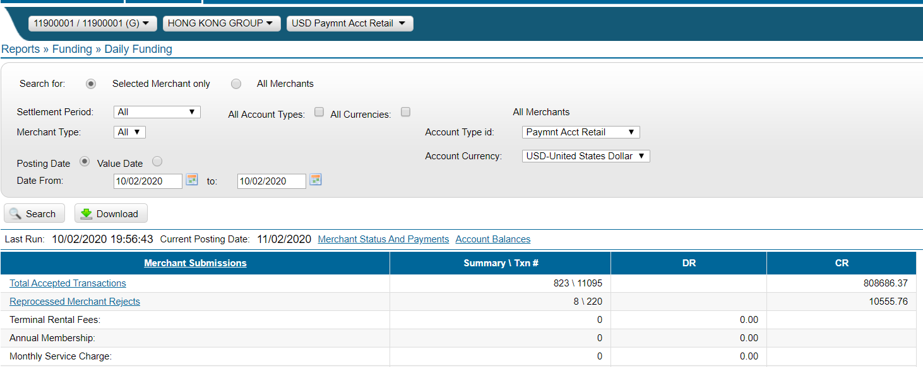

**For Posting Date for 12900001 - MOP PAR for Macau**

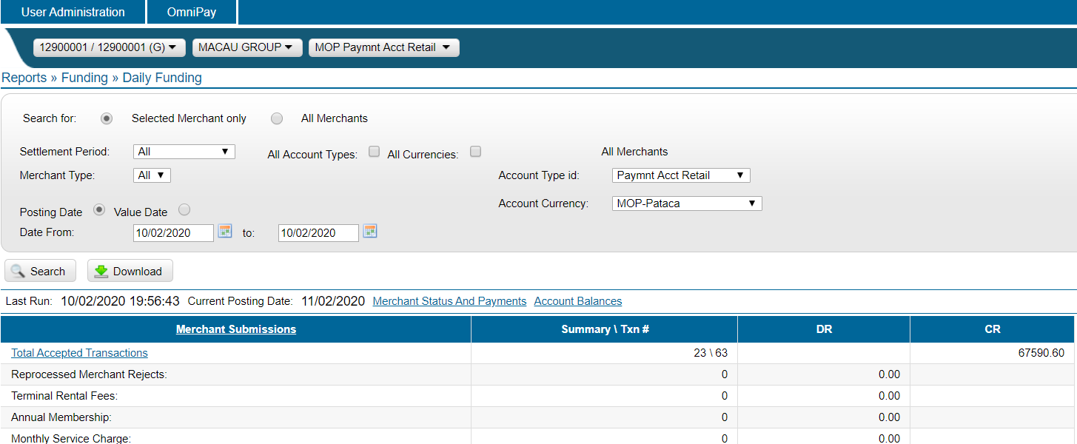

**For Posting Date for 13900001 -SGD PAR for Singapore**

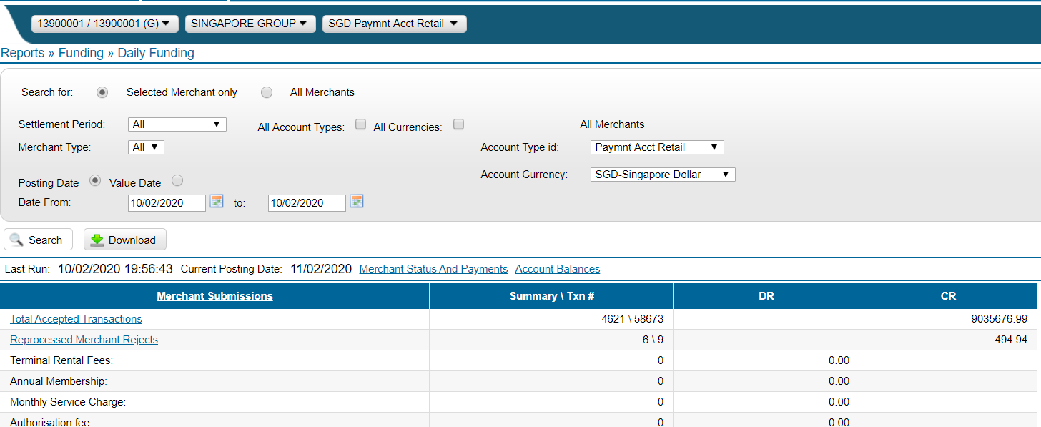

**For Posting Date for 13900001 -USD PAR for Singapore**

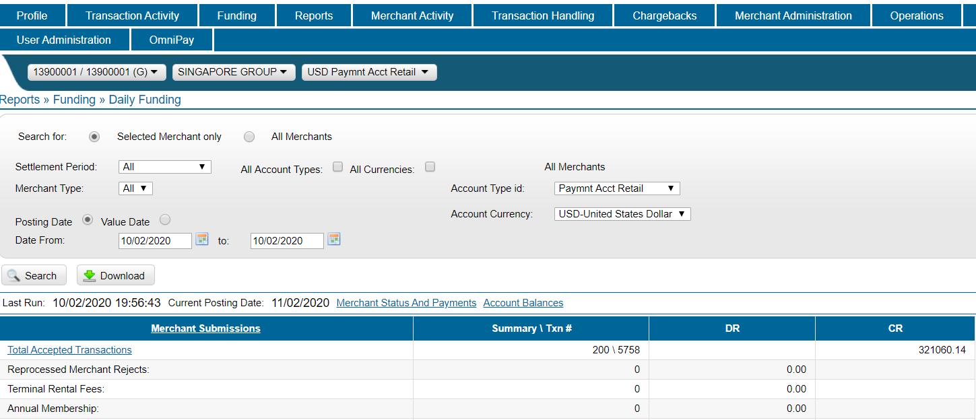

**For Posting Date for 15900001 - MYR PAR for Malaysia**

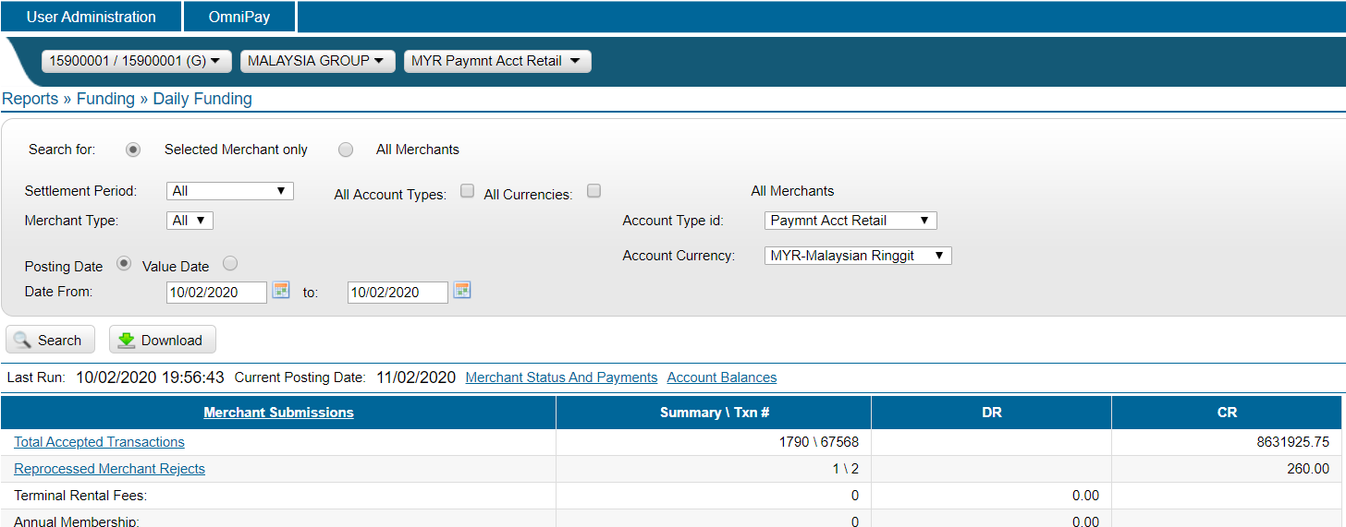

**For Posting Date for 20900001-HK CITIC for HongKong**

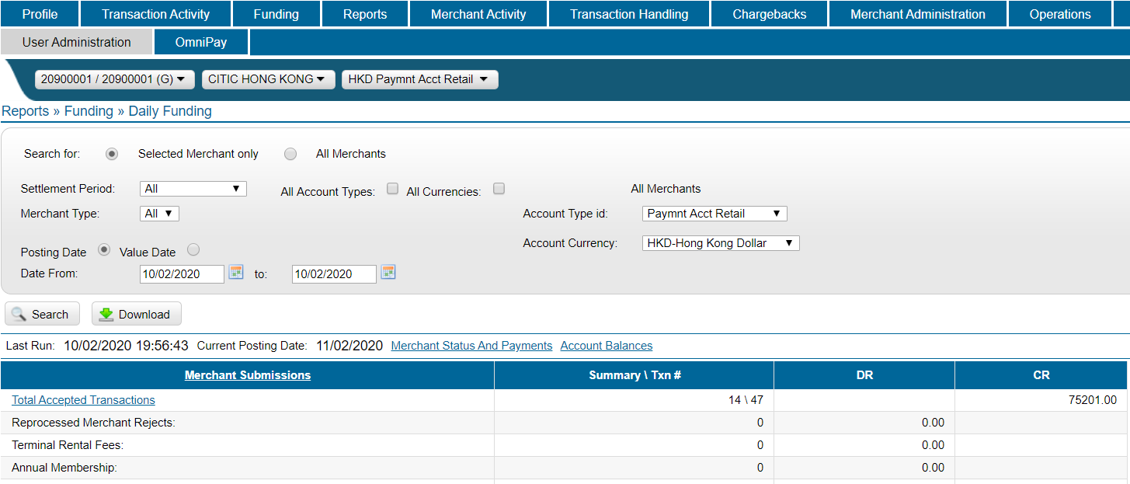

**Transaction Activity » Processed Transactions**

**For Posting Date for**

1. **Hong Kong country group ID - 11900001 - HKD PAR & USD PAR**
2. **Macau country group ID - 12900001 - MOP PAR**
3. **Singapore country group ID - 13900001-SGD PAR & USD PAR**
4. **Malaysia country group ID - 15900001 - MYR PAR**
5. **CITIC Hong Kong country group ID - 20900001-HK PAR**

**Please refer the below for Example**

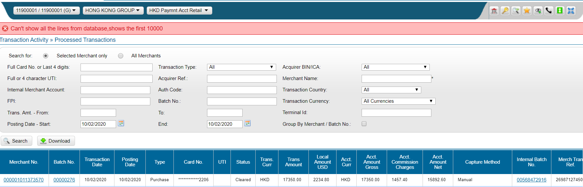

1. **Reports » Funding » Merchant Payment Advice**

**For Posting Date for**

1. **Hong Kong country group ID - 11900001 - HKD PAR & USD PAR**
2. **Macau country group ID - 12900001 - MOP PAR**
3. **Singapore country group ID - 13900001-SGD PAR & USD PAR**
4. **Malaysia country group ID - 15900001 - MYR PAR**
5. **CITIC Hong Kong country group ID - 20900001-HK PAR**

**Please refer the below for Example**

